DEVELOPMENT OF A LOCALIZED REAL-TIME

FREQUENCY MONITORING SYSTEM FOR STRUCTURAL

HEALTH MONITORING USING MEMS IMUS AND ESP32

Presented to the faculty of
College of Engineering and Architecture
CAGAYAN STATE UNIVERSITY
Carig, Campus
Tuguegarao City, Cagayan

In Partial Fulfillment
of the Requirements for the Degree
BACHELOR OF SCIENCE IN ELECTRONICS ENGINEERING

JAN CLYDE T. TALOSIG

August 2026

APPROVAL SHEET
This thesis titled “Development of a Localized Real-Time Frequency Monitoring System for Structural Health Monitoring using MEMS IMUs and ESP32”, prepared and submitted by JAN CLYDE T. TALOSIG in partial fulfilment of the requirements for the degree, Bachelor of Science in Electronics Engineering, is hereby recommended for final defense.

ENGR. CRISTOPHER R. CAPILI
Adviser

Approved by the Tribunal on Oral Examination with a grade of _______.

ENGR. GIVEN M. LAST NAME
Chairman

ENGR. GIVEN M. LAST NAME ENGR. GIVEN M. LAST NAME
Member Member

ENGR. EULOGIO NEIL A. MALLILLIN
Department Chair

Accepted and approved partial fulfillment of the requirements for the degree, Bachelor of Science in Electronics Engineering.

September 02, 2026 ENGR. JOHN MICHAEL B. CASIBANG Date Dean, College

DEDICATION
This section is a personal note where the researcher dedicates the work to individuals or groups who provided inspiration, support, or motivation. It is usually written in a heartfelt and informal tone compared to the rest of the manuscript.

JAN CLYDE T. TALOSIG

Researcher

ACKNOWLEDGEMENT
This section expresses gratitude to those who contributed to the completion of the study. It can include advisers, faculty members, classmates, family, friends, and institutions. The tone is formal but appreciative.

TABLE OF CONTENTS
APPROVAL SHEET ii
DEDICATION iii
ACKNOWLEDGEMENT iv
TABLE OF CONTENTS v
LIST OF TABLES vii
LIST OF FIGURES viii
ABSTRACT ix
CHAPTER I 1
THE PROBLEM AND ITS BACKGROUND 1
1.1 Introduction 1
1.2 Statement of the Problem 4
1.3 Objective of the Study 5
1.4 Conceptual Framework of the Study 5
1.5 Significance of the Study 7
1.6 Scope and Delimitation 9
1.7 Definition of Terms 11
CHAPTER II 14
REVIEW OF RELATED LITERATURE 14
2.1. Introduction 14
2.2. Vibration-Based Structural Health Monitoring of Bridges 15
2.2.1 Structural Health Monitoring and Dynamic Response 15
2.2.2 Natural Frequency, Modal Parameters, and Structural Properties 17
2.3. Impact of Operational and Measurement Variability 18
2.3.1 Environmental and Operational Effects on Frequency Interpretation 18
2.4. Monitoring and Analysis Approaches 19
2.4.1 Operational Modal Analysis and Frequency-Domain Identification 19
2.4.2 Fast Fourier Transform and Vibration Signal Processing 21
2.4.3 Low-Cost MEMS Accelerometers for Bridge Monitoring 22
2.4.4 Real-Time, Wireless, and IoT-Enabled SHM 25
2.4.5. Verification, Baselines, and Statistical Limits 26
2.5. Philippine and Buntun Bridge Context 27
2.5.1 Philippine Applications of Sensor-Based Bridge SHM 27
2.5.2 Philippine Real-Time Monitoring and Institutional Developments 28
2.5.3 Bounded Research Gap and Relevance to Buntun Bridge 28
2.6. Synthesis and Study Gap 29
CHAPTER III 32
METHODOLOGY 32
3.1 General Overview 32
3.2 Study Area 33
3.3 Research Design 34
3.4 System Architecture and Materials 35
3.5 Field Measurement Units and Sampling Plan 41
3.6 Research Instrument and Sensor Installation 43
3.7 Data Gathering Procedure 44
3.8 Traffic-Condition Characterization 47
3.9 Signal Processing and Dominant-Frequency Extraction 51
3.10 Baseline Frequency Construction 53
3.11 Statistical Treatment 55
3.12 Reliability and Repeatability Assessment 56
3.13 Data Quality Control and Acceptance Criteria 57
3.14 Ethical, Safety, and Site Considerations 57
3.15 Summary of the Methodological Framework 58
CHAPTER IV 60
RESULTS AND DISCUSSION 60
4.1 Introduction 60
4.2 System Acquisition and Processing Performance 60
4.3 Roadway-Deck Frequency by Traffic-Count Group 60
CHAPTER V 61
CONCLUSION AND RECOMMENDATIONS 61
5.1 Summary 61
5.2 Conclusion 61
5.3 Recommendations 61
REFERENCES 62

LIST OF TABLES
Table No. Title of Table Page
1. Required documentation of the final monitoring-system configuration 36
2. Minimum field information recorded for each measurement session 43
3. Vibration-acquisition protocol summary 46
4. Pilot-derived traffic-group rules 48

LIST OF FIGURES
Figure No. Title of Figure Page
1.1. Conceptual Input-Process-Output Framework of the SHM System 6
1.2. Buntun Bridge study site 10
3.1. Single-Board System and Firmware Data Path 37
3.2. Device schematic diagram 38
3.3. PCB layout and 3D CAD view 38
3.4. Current firmware session-control and window-processing flowchart 40
3.5. Field Data Collection and Evaluation Flowchart 53

ABSTRACT
TITLE : DEVELOPMENT OF A LOCALIZED REAL-TIME FREQUENCY MONITORING SYSTEM FOR STRUCTURAL HEALTH MONITORING USING MEMS IMUS AND ESP32
RESEARCHER : JAN CLYDE T. TALOSIG
INSTITUTION : CAGAYAN STATE UNIVERSITY CARIG CAMPUS
DEGREE : BACHELOR OF SCIENCE IN ELECTRONICS ENGINEERING
YEAR : 2026
ADVISER : ENGR. CRISTOPHER R. CAPILI, MSECE
This developmental study aims to develop and field-evaluate a localized system for recording roadway-deck vibration-frequency indicators on Buntun Bridge in Tuguegarao City, Cagayan. The preliminary design uses one PCB carrying an ESP32-S3 and three co-located triaxial MPU-6050 IMU ICs. The board will be secured at one predeclared roadway-deck station, subject to survey, safe mounting, and site authorization. Each field session will last 10 minutes while a separate observer tallies vehicles at a safe viewpoint. Pilot counts will define and freeze the local NEAR_ZERO, MEDIUM, and HEAVY groups before formal collection; these labels are not universal traffic classes. Vibration records will be divided into pilot-checked 60-second analysis windows. Arduino IDE firmware will poll the three channels sequentially, timestamp X/Y/Z readings, and apply mean removal, a fixed window, FFT magnitude, and the largest positive-frequency bin within a predeclared band. Valid window estimates will be summarized per session, channel, and axis. The mean and sample standard deviation will describe baseline spread; a separate two-standard-deviation band will prompt review only. The study evaluates acquisition, repeatability, and visualization; it does not diagnose damage or assess bridge safety. No field results are reported in this draft.

Keywords: Buntun Bridge; roadway-deck vibration; dominant spectral frequency; FFT; MEMS IMU

CHAPTER I

THE PROBLEM AND ITS BACKGROUND

1.1 Introduction
Buntun Bridge connects Tuguegarao City and Solana, and the Philippine Information Agency identifies its importance to commuters, emergency responders, and the business sector (Baccay, 2025). At the national level, the Philippines has high exposure to geophysical and hydrometeorological hazards, including earthquakes, typhoons, floods, and landslides (Organisation for Economic Co-operation and Development [OECD], 2024). This national hazard context does not establish damage at a particular bridge. Long-term monitoring research shows that temperature and operating conditions can influence measured modal properties, so a change in a vibration indicator requires contextual interpretation before it is attributed to deterioration (Sohn, 2007; Deraemaeker et al., 2008; Moser & Moaveni, 2011).
The Department of Social Welfare and Development’s March 1, 2025 situation report records the February 27 collapse of the Cabagan–Sta. Maria Bridge and six affected persons. In its February 28 report, the Philippine News Agency stated that DPWH Region II had requested experts from the central-office Bureau of Design and Bureau of Construction for further evaluation and assessment; DPWH said its analysis to determine the cause was still ongoing at that time (Department of Social Welfare and Development, 2025; Patinio, 2025).
The Piggatan Bridge in Alcala, Cagayan, collapsed on October 6, 2025. A later government report documents the event while announcing the opening of a detour bridge (Presidential Communications Office, 2025). This provides regional context; it does not show that this study's system could have predicted the collapse.
Buntun Bridge, opened in 1969 and spanning 1,369 meters, remains a direct route between Tuguegarao City and Solana. In early 2025, authorities limited truck loads to 15 tons. This study uses the bridge as a field site for recording roadway-deck vibration-frequency behavior under naturally occurring traffic; it does not assess the bridge’s safety or load capacity (Baccay, 2025).
These reports provide regional context, but they do not show that the monitoring system in this study could have predicted or prevented the reported bridge failures. The present study, therefore, addresses a narrower task: recording and characterizing roadway-deck vibration-frequency behavior at a fixed Buntun Bridge station under observed traffic conditions.
Structural Health Monitoring (SHM) has emerged as a modern engineering approach for assessing the condition of structures through continuous or periodic measurement of structural responses (Brownjohn, 2007; Farrar & Worden, 2007). Among various SHM techniques, frequency-based monitoring is widely recognized as a method for observing structural dynamic changes (Avci et al., 2021; Azhar et al., 2024). The natural frequencies of a structure depend on its mass and stiffness; therefore, damage such as cracking, corrosion, or joint degradation can alter frequency characteristics (Salawu, 1997; Doebling et al., 1996; Carden & Fanning, 2004). Vibration signals can be transformed for frequency analysis: the Fast Fourier Transform (FFT) computes the discrete Fourier transform efficiently, while Welch’s method estimates power spectra by averaging modified periodograms (Cooley & Tukey, 1965; Welch, 1967). A selected peak is still an observed spectral feature whose interpretation depends on the signal and measurement conditions (Hasani & Freddi, 2023; Rainieri & Fabbrocino, 2014).
Published bridge-monitoring studies describe varied sensor, data-acquisition, embedded-processing, and communication architectures, including low-cost MEMS-based field systems (Komarizadehasl et al., 2022a; Hidalgo-Fort et al., 2024; Giermann et al., 2025). Measurement limitations and deployment conditions need to be evaluated for each implementation. This study develops and field-evaluates a localized prototype using MEMS IMUs, an ESP32-S3, Arduino IDE firmware, and web visualization on Buntun Bridge. It characterizes dominant spectral-frequency indicators under the observed NEAR_ZERO, MEDIUM, and HEAVY traffic categories; it does not evaluate existing inspection practices or claim to replace structural inspection.
To address this applied development need, this study proposes a localized real-time frequency-monitoring system using one PCB with an ESP32-S3 and three co-located triaxial MEMS IMU ICs. The single board will be mounted at one fixed roadway-deck station. Arduino IDE firmware will poll the three channels sequentially, process each channel-axis record using the thesis’s FFT peak-selection method, and send session summaries to a web interface. A concurrent visual vehicle tally will describe the traffic observed during fixed-duration sessions. The system will characterize local dominant spectral-frequency indicators without claiming a bridge-wide modal survey, structural diagnosis, or explanation of previous bridge failures.

1.2 Statement of the Problem
Bridge SHM research supports vibration-based observation of structural response, while measured frequency indicators can vary with operating and measurement conditions (Brownjohn, 2007; Sohn, 2007; Hasani & Freddi, 2023). The practical problem addressed by this developmental study is how to develop and evaluate a single-station system that produces traceable roadway-deck vibration-frequency indicators with concurrent traffic-count context at Buntun Bridge. The study evaluates the prototype and describes the recorded indicators; it does not diagnose structural damage or assess bridge safety. Specifically, it seeks to answer the following questions:
- What single-board system can be developed to acquire, process, store, and present roadway-deck vibration records with traffic-count context at one fixed Buntun Bridge station?
- To what extent does the prototype meet predeclared criteria for record completeness, acquisition timing, offline-processing agreement, repeatability, and dashboard output?
- What dominant in-band spectral-frequency indicators are observed for each onboard channel and axis, and how do the session-level summaries vary descriptively across locally defined traffic-count groups?

1.3 Objective of the Study
This developmental study aims to develop and evaluate a localized frequency-monitoring prototype for roadway-deck vibration at Buntun Bridge and to describe its recorded frequency indicators in traffic-count context. Specifically, it aims to:
- Develop and document a single-board prototype with three co-located triaxial MEMS IMU channels, embedded acquisition and frequency processing, session storage, and web-based reporting for one fixed roadway-deck station.
- Evaluate the prototype against predeclared criteria for record completeness, acquisition timing, offline-processing agreement, repeatability, and dashboard/session-log output.
- Describe the observed dominant in-band spectral-frequency indicators by onboard channel and axis, and summarize them by session and pilot-defined local traffic-count group without treating the categories as structural load classes.

1.4 Conceptual Framework of the Study
In structural dynamics, modal frequencies depend on structural mass and stiffness; changes in physical properties may therefore change modal behavior. The dominant peak in an operational roadway-deck vibration record, however, is a local observed spectral indicator. Excitation, roadway-surface condition, environmental and operational conditions, sensor characteristics, and measurement noise can also change measured peaks. Accordingly, this study treats a peak shift as a change in the recorded indicator that warrants review, not as proof of a particular damage mechanism or structural condition (Sohn, 2007; Hasani & Freddi, 2023; Camara et al., 2017).
The conceptual framework of the developed system follows an Input–Process–Output (IPO) model, illustrated in Figure 1.1. Figure 1.1 depicts the system pipeline, not the step-by-step procedure for conducting the research. The field procedure is described in Section 3.7 and summarized in Figure 3.5.
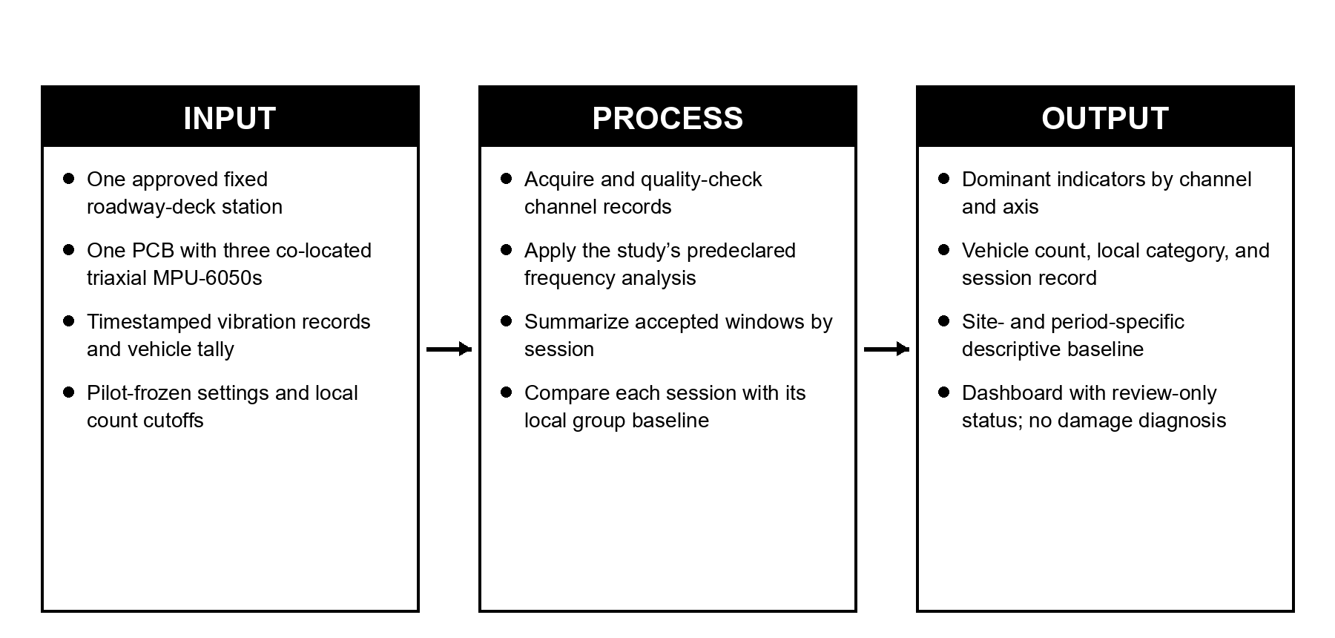
Figure 1.1. Conceptual Input-Process-Output Framework of the SHM System
In the Input stage, naturally occurring traffic and other ambient excitation produce roadway-deck vibration at the predefined Buntun Bridge station. One rigid sensing PCB carrying three co-located triaxial IMUs records that local response. A separate observer tallies vehicle passages during the same 10-minute session.
During processing, the ESP32-S3 polls onboard IMU channels in the fixed sequence 1, 2, 3; each reading is tagged by channel, axis, sample index, timestamp, and scan-cycle ID. The session is divided into ten 60-second analysis windows. Each channel-axis window is timing-checked and processed using the fixed FFT settings. The system associates its valid window estimates with the session’s pilot-defined traffic-count group and compares the session summary with the matching baseline; a value outside the review band is flagged for human review only.
In the Output stage, per-session roadway-deck frequency indicators, vehicle-count context, and review status are transmitted to a web-based interface and retained in the session log.
This framework concerns one local roadway-deck station and the development of its acquisition, frequency-extraction, and visualization pipeline. The three onboard channels are co-located on one rigid board; the study does not estimate spatial mode shapes or claim to measure the bridge’s global response.

1.5 Significance of the Study
This study contributes a developmental prototype for localized roadway-deck vibration-frequency monitoring in the Philippines. One PCB with three co-located triaxial MEMS IMUs and an ESP32-S3 will acquire and process vibration data for web-based display. Its field reliability, long-term performance, and suitability as an alternative to existing SHM systems remain to be evaluated.
To residents and commuters in Tuguegarao City and Solana, this study may provide a documented record of Buntun Bridge roadway-deck vibration-frequency behavior at the selected station under the observed NEAR_ZERO, MEDIUM, and HEAVY traffic categories. The prototype is a research instrument; it does not determine whether the bridge is safe or replace inspections, load restrictions, maintenance decisions, or emergency management.
For engineers and infrastructure inspectors, the prototype is intended to provide logged roadway-deck vibration-frequency observations that may supplement visual inspections. This study does not validate an automated condition assessment, maintenance decision rule, or change to inspection intervals.
For DPWH and other government agencies responsible for bridge maintenance, this study documents a prototype data-acquisition and display workflow designed to establish an empirical, site-specific roadway-deck frequency baseline. The measurements may support future monitoring research, but this study does not validate a maintenance decision rule, assess structural safety, or justify changes to inspection intervals.
For the local economy and communities in Region 2, this thesis documents development of a prototype intended to record Buntun Bridge roadway-deck vibration-frequency behavior under observed traffic. The study does not evaluate whether using this system could prevent bridge closures or reduce economic disruption.
For the academic and engineering research community, this thesis documents a localized single-board prototype and field procedure for collecting and summarizing roadway-deck vibration-frequency indicators at one fixed Buntun Bridge station using three co-located triaxial IMU channels, embedded FFT processing, and web visualization. Future work may evaluate other structures, spatial sensor arrangements, or damage-related indicators; these are outside this study.
The prototype uses locally accessible components as a developmental approach to bridge-frequency monitoring. Its cost, reliability, and scalability will need to be evaluated before broader deployment can be claimed.

1.6 Scope and Delimitation
This study develops and evaluates a localized frequency-monitoring system using one PCB carrying an ESP32-S3 and three co-located triaxial MEMS IMU ICs. The single board will be installed at the predefined roadway-deck station shown by the red map marker in Figure 1.2. The external field supply connects through the board’s USB-C receptacle, which also provides the ESP32-S3 USB programming connection; field summaries use the separate wireless path. Firmware polls channel 1, channel 2, and channel 3 in that order. Timestamp and scan-cycle fields support traceability; the readings are sequential, not simultaneous, and the co-located channels do not form a spatial bridge array.
The system will be tested on Buntun Bridge in Tuguegarao City, Cagayan, at the mapped roadway-deck station shown in Figure 1.2. The red map marker is an approximate map reference, not a surveyed coordinate. The study’s performance and extracted frequency characteristics are specific to this single site and the documented station; they are not claimed to generalize to bridges of different structural types, spans, or material conditions without further testing.
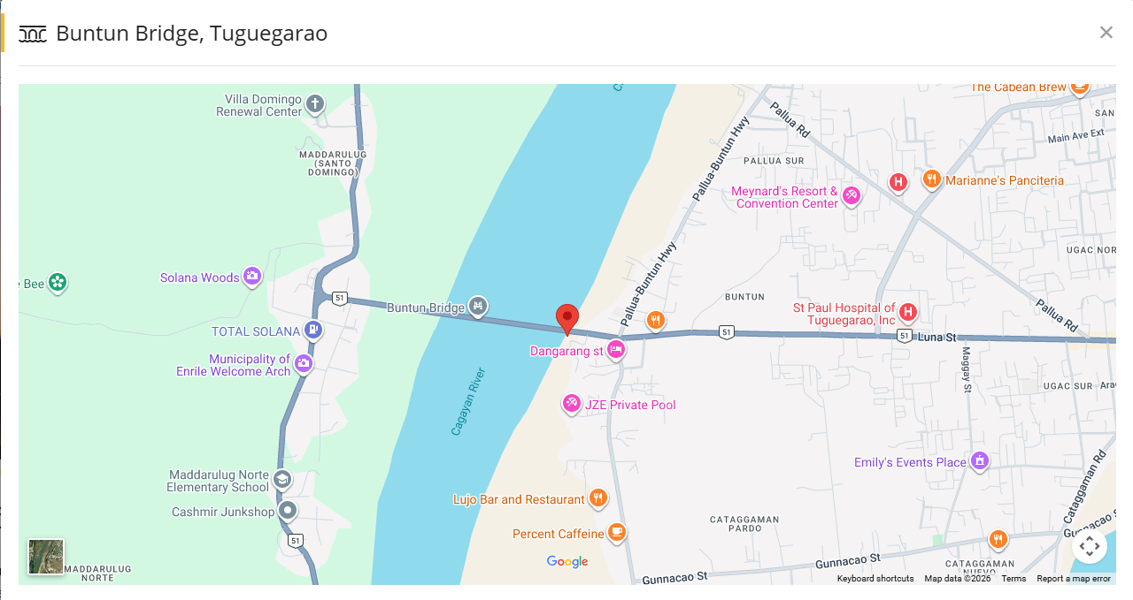
Figure 1.2. Buntun Bridge study site; the red map marker indicates the approximate planned roadway-deck measurement station.
The sources located and reviewed for this draft did not identify a documented instrumented baseline for Buntun Bridge as of 29 October 2026; this review does not establish that none exists. This study will construct a descriptive baseline from its own recorded data, internal to the device and deployment, and not validated against an external reference sensor or independently verified ground truth.
The study is limited to frequency-based monitoring and does not include structural diagnosis, damage classification, predictive modeling, load-capacity analysis, or repair recommendations. Interpretation of any observed frequency shift as a specific damage type or severity level is outside the scope of this study.
The system is further limited by hardware constraints such as processing speed, memory capacity, sensor resolution, sequential acquisition, and the fact that the three IMUs are co-located on one PCB. Environmental factors such as temperature, humidity, wind, electromagnetic interference, roadway-surface condition, and vehicle-pavement interaction are not fully incorporated into the analysis; relevant conditions will be recorded as context when practicable. Data collection is also limited to the specific station, dates, and traffic sessions observed and will not capture the full range of seasonal, weather-related, spatial, or long-term structural variation.

1.7 Definition of Terms
Baseline Frequency Range: $\bar{x}± s$ The descriptive spread of dominant spectral-frequency estimates for a specified traffic category, sensor, and axis, used as an internal reference for later observations from the same stratum.
Excitation: An external force or disturbance, such as vehicular traffic, wind, or ambient vibration, that causes a structure to vibrate and produce a measurable dynamic response.
ESP32-S3: A microcontroller used for data acquisition, processing, and wireless communication in the system.
Fast Fourier Transform (FFT): A signal processing technique used to convert time-domain signals into frequency-domain data.
Frequency Monitoring: The process of analyzing roadway-deck vibration signals to extract dominant spectral-frequency indicators. An FFT-selected peak in this study is not automatically identified as a natural frequency or structural mode.
Dominant Spectral-Frequency Indicator: The frequency of the largest magnitude positive-frequency FFT bin within the predeclared analysis band for one sensor-axis record; it is a measured spectral feature and is not automatically a verified natural frequency or mode.
Localized (System): In this study, “localized” describes a site-specific prototype planned for one predefined roadway-deck station at Buntun Bridge. It does not establish local component sourcing, comparative affordability, or maintenance feasibility.
MEMS IMU (Micro-Electro-Mechanical Systems Inertial Measurement Unit): A device containing inertial sensors. In this study, each MPU-6050 IC provides triaxial acceleration and angular-rate channels; the frequency analysis uses acceleration data from three co-located ICs on one PCB.
Natural Frequency: The inherent frequency at which a structure vibrates in a particular mode when disturbed, determined by its physical properties and boundary conditions. An operational roadway-deck spectral peak is not automatically equivalent to a verified natural frequency.
Real-Time Monitoring: In this study, the term describes live session status, latest sensor readings, and the latest completed analysis window displayed on a local dashboard. End-to-end update latency, reliability, and time-critical performance have not been characterized.
Resonant Frequency: The frequency at which a structure experiences maximum vibration amplitude due to external excitation.
Structural Health Monitoring (SHM): A method of evaluating the condition of a structure through measurement and analysis of its response.
Vibration Signal: The raw time-domain data captured by the sensor, representing the structure’s motion or acceleration over time, prior to frequency-domain processing.
Traffic-count group: A study-local label assigned from the total number of vehicles counted during one fixed 10-minute session. NEAR_ZERO denotes the lowest pilot-observed count band; MEDIUM and HEAVY denote the next two bands. The names are not universal thresholds and must be tied to the frozen local cutoffs.

CHAPTER II

REVIEW OF RELATED LITERATURE
This thematic review follows a problem-to-evaluation sequence. It first introduces bridge SHM and dynamic-response indicators, then examines how environmental, operational, and measurement variability affects their interpretation. It next reviews OMA, spectral processing, MEMS sensing, and connected monitoring architectures as possible approaches, followed by evidence on verification, descriptive baselines, and statistical limits. Philippine applications and Buntun Bridge context are considered before stating the gap found within the sources identified for this review. This is a focused narrative review, not a claim of an exhaustive systematic search.

2.1. Introduction
Bridge SHM literature describes measurement-based systems that combine sensing, data acquisition, signal processing, modal identification, and decision support to observe structural response during service (Brownjohn, 2007; Ko & Ni, 2005; Farrar & Worden, 2007; Azhar et al., 2024). Vibration monitoring is one approach within that broader field (Brownjohn, 2007; Farrar & Worden, 2007). Its relevance depends on the monitoring objective and on how measured response is interpreted; a monitoring result alone does not establish a damage diagnosis (Carden & Fanning, 2004; Farrar & Lieven, 2007).
The reviewed literature also shows that frequency-based monitoring is not a matter of obtaining a spectral peak and treating every change as damage. Structural condition and environmental or operational conditions can affect modal properties and the frequencies identified from response data; sensor characteristics and measurement noise can also affect measured signals and the uncertainty of the resulting estimates (Sohn, 2007; Chen et al., 2017; Wang et al., 2022). This distinction matters for the present study because its baseline will be established on an operating bridge under naturally occurring traffic and other ambient conditions. Repeated observations and explicit characterization of operational variability are therefore relevant, but the cited literature does not establish that the present prototype can separate these influences (Sohn, 2007; Deraemaeker et al., 2008; Wang et al., 2022).

2.2. Vibration-Based Structural Health Monitoring of Bridges

2.2.1 Structural Health Monitoring and Dynamic Response
SHM uses measured structural response to track behavior or condition; vibration-based methods use changes in modal features such as frequency or mode shape as candidate indicators of altered structural properties (Farrar & Worden, 2007; Brownjohn, 2007; Das et al., 2016; Avci et al., 2021). Reviews also describe limits in identifying damage from vibration alone (Doebling et al., 1996, 1998; Salawu, 1997; Fan & Qiao, 2011; Carden & Fanning, 2004; Sohn et al., 2004). An observed frequency change is evidence of changed response, not a unique diagnosis; the inference from response to condition requires additional evidence (Ko & Ni, 2005; Worden et al., 2007; Farrar & Lieven, 2007).
Ambient and operational inputs such as traffic and wind can provide response measurements without a dedicated excitation device (Hasani & Freddi, 2023; Rainieri & Fabbrocino, 2014). OMA methods estimate modal properties from output measurements under these operating conditions (Hasani & Freddi, 2023; Rainieri & Fabbrocino, 2014). This is relevant to in-service bridges, although results remain dependent on the recorded response, sensor arrangement, excitation, and identification method.
The literature nevertheless distinguishes monitoring from diagnosis (Doebling et al., 1996, 1998; Salawu, 1997). A frequency change may indicate that the dynamic behavior has changed, but a frequency shift alone generally does not identify a unique damage mechanism or severity (Doebling et al., 1996, 1998; Salawu, 1997; Moravvej & El-Badry, 2024). Reference-free damage-detection research emphasizes that reliable diagnosis is more difficult when an intact reference state is unavailable and when environmental or operational effects overlap with damage-related changes (Moravvej & El-Badry, 2024). This distinction supports the present study's limitation to frequency monitoring and baseline characterization rather than structural damage classification. Environmental and operational changes, as well as sensor faults, can complicate attribution; these explanations must be distinguished from structural damage (Deraemaeker et al., 2008; Kullaa, 2011; Yan et al., 2005a, 2005b). Long-term studies at Alamosa Canyon and the Z24 Bridge distinguish environmental frequency variation from damage-related changes; these are precedents for cautious interpretation, not thresholds transferable to Buntun (Cornwell et al., 1999; Peeters & De Roeck, 2001; Sohn et al., 1999).

2.2.2 Natural Frequency, Modal Parameters, and Structural Properties
Natural frequencies are related to a structure’s mass, stiffness, and boundary conditions (Deng et al., 2023). A bridge has multiple modal frequencies and associated mode shapes, and changes in structural properties may alter these modal parameters (Deng et al., 2023; Wang et al., 2022; Azhar et al., 2024). Full-scale studies report that identified bridge frequencies can vary with temperature, traffic, and vehicle loading; the observed effect is site- and condition-specific and cannot be transferred as a numerical threshold for Buntun Bridge (Moser & Moaveni, 2011; Cantero et al., 2017, 2019; Li et al., 2003; Górski et al., 2020; Furtmüller et al., 2022).
A prominent peak in an operational spectrum is not automatically a verified natural frequency or mode. The measured spectrum reflects both the structure and the excitation, and closely spaced modes or weak/noisy response can make peak interpretation ambiguous (Chen et al., 2017; Hasani & Freddi, 2023; Rainieri & Fabbrocino, 2014). The present study therefore uses the term dominant spectral-frequency indicator for its selected FFT bin.

2.3. Impact of Operational and Measurement Variability

2.3.1 Environmental and Operational Effects on Frequency Interpretation
Bridge modal frequencies can vary during service with environmental and operational conditions, including temperature and traffic loading (Sohn, 2007; Deraemaeker et al., 2008; Wang et al., 2022). Long-term records and bridge studies report such variability, including traffic- and temperature-related changes; these results are site-specific and are not numerical thresholds transferable to Buntun Bridge (Cornwell et al., 1999; Sohn et al., 1999; Peeters & De Roeck, 2001; Cross et al., 2013; Furtmüller et al., 2022; Górski et al., 2020; Li et al., 2003).
Traffic is both an operational input and a source of variability in measured response (Kim et al., 2003; Chang et al., 2014; Wang et al., 2022). Long-term bridge studies report traffic- and temperature-related modal-frequency variation, while vehicle mass and parked vehicles have also been associated with changes in measured bridge dynamics (Zhou & Sun, 2019; Kim et al., 2003; Chang et al., 2014). These precedents support recording traffic context; they do not establish that a vehicle-count band measures structural load or explains a local frequency change.
For this study, traffic is represented by three locally defined vehicle-count groups based on equal-duration pilot observations. FHWA describes traffic volume as the number of vehicles passing a point during a defined interval and allows multiple reporting intervals; this supports retaining the count and interval, not the use of a 10-minute vibration session or the study-specific NEAR_ZERO, MEDIUM, and HEAVY cutoffs (Federal Highway Administration, 2013, 2022a, 2022b). The cutoffs will be frozen before formal collection.
These categories describe observed traffic volume only, not vehicle mass, axle configuration, structural load, or calibrated excitation (Kim et al., 2003; FHWA, 2022a). The resulting baseline is local to the monitored station, category definitions, and study period.

2.4. Monitoring and Analysis Approaches

2.4.1 Operational Modal Analysis and Frequency-Domain Identification
Operational Modal Analysis estimates modal characteristics from structural response measurements while the structure is subjected to ambient or operating loads (Rainieri & Fabbrocino, 2014; Reynders, 2012). For bridges, common output-only identification methods include Peak Picking (PP), Frequency Domain Decomposition (FDD), and Stochastic Subspace Identification (SSI) (Peeters & De Roeck, 1999; Reynders, 2012). Hasani and Freddi (2023) report that PP is the simplest frequency-domain approach and identifies candidate modal frequencies from peaks in response spectra. FDD extends frequency-domain analysis by decomposing the spectral density matrix, allowing more complex modal behavior to be separated (Brincker, Zhang, et al., 2001). SSI operates in the time domain and can provide robust modal identification and mode shapes, although it is more computationally demanding (Peeters & De Roeck, 1999; Reynders, 2012). Reference-based stochastic subspace identification and frequency-domain decomposition are established output-only modal-identification approaches (Peeters & De Roeck, 1999; Deraemaeker et al., 2008; Magalhães et al., 2007; Reynders, 2012). The present firmware instead selects the largest positive FFT bin within a band; this is a spectral indicator and does not by itself perform full OMA. Frequency Domain Decomposition uses spectral-density matrix decomposition for output-only modal identification, and related work describes estimating damping from decomposed response spectra; neither procedure is implemented by the present single-bin estimator (Brincker, Zhang, et al., 2001; Brincker, Ventura, et al., 2001).
Chen et al. (2017) demonstrated the practical value and limitations of these approaches on an eleven-span concrete bridge under weak ambient excitation. Using inexpensive accelerometers, they identified multiple modal frequencies below 10 Hz despite weak excitation and measurement noise. Their comparison showed that Peak Picking could identify a large number of frequencies efficiently, while SSI produced higher-quality mode-shape information at higher computational cost. This finding is directly relevant to an embedded real-time system: a lightweight peak-picking approach can be reasonable for preliminary or continuous monitoring when computational resources are limited, provided that the limitations of the method are explicitly acknowledged. Bridge field studies have used dynamic tests and automated modal identification to characterize full-scale structures, including the Tamar suspension bridge; these system-specific deployments do not validate the present board or estimator (Cunha et al., 2001; Koo et al., 2013; Magalhães et al., 2009, 2012). In a separate Alamosa Canyon Bridge field study, wireless units were tested alongside a cable-based commercial system during controlled excitation; this comparison is precedent for validation practice, not evidence for the current hardware (Lynch et al., 2003).
The literature further indicates that frequency-domain peak identification is most dependable when modal peaks are reasonably separated and the measured response has adequate signal-to-noise ratio. Closely spaced modes, harmonics, local vibration sources, and noise can create ambiguous peaks or shift the apparent maximum. For that reason, the present study should treat the selected spectral peak as a dominant frequency estimate generated by a defined processing procedure, rather than claiming that simple peak picking is universally equivalent to full modal identification (Hasani & Freddi, 2023; Azhar et al., 2024). Mode interaction, operational loading, and long-term variability can complicate peak interpretation; a peak shift alone is not a diagnosis (Magalhães et al., 2007; Cross et al., 2013; Soyoz & Feng, 2009).

2.4.2 Fast Fourier Transform and Vibration Signal Processing
The FFT is an efficient algorithm for computing the DFT, converting sampled time records into frequency-domain values that can be inspected for spectral peaks (Cooley & Tukey, 1965; Hasani & Freddi, 2023). Welch’s method is a separate PSD estimator that averages modified periodograms; it is not the estimator used by the current firmware (Welch, 1967). Window choice affects leakage and peak width (Harris, 1978; Bendat & Piersol, 2011). These sources do not establish that the firmware’s symmetric Hann setting is optimal for this sensor and bridge; the manuscript/code setting must be reconciled and then checked with pilot data.
Offset removal and other preprocessing choices affect the signal supplied to frequency analysis; sample timing and record length also constrain the representable band and frequency-bin spacing (Bendat & Piersol, 2011; Chen et al., 2017; Hasani & Freddi, 2023). Oth and Picozzi (2012) used 100 samples per second and one-minute PSD windows in a particular Adolphe Bridge deployment; this is a precedent, not evidence that the same settings are adequate for this sensor or site. Calibration against a reference transducer is a separate metrology procedure (International Organization for Standardization, 2003). ISO 16063-21:2003 describes comparison calibration, but does not establish calibration of the project sensors.
Embedded processing balances computation, memory, latency, and data-transfer needs (Hidalgo-Fort et al., 2024; Rice et al., 2010, 2011). Published systems show that selected processing can be performed near the sensor node, but each architecture has its own measured performance and deployment limits (Hidalgo-Fort et al., 2024; Lynch, 2007; Rice et al., 2010, 2011; Whelan et al., 2009; Whelan & Janoyan, 2009; Lynch & Loh, 2006; Spencer et al., 2004; Nagayama & Spencer, 2007; Pakzad et al., 2008). Espressif’s module datasheet and serial-connection documentation describe component-level capabilities and setup only; they do not verify the assembled PCB, sensor timing, or field performance (Espressif Systems, 2026, n.d.).

2.4.3 Low-Cost MEMS Accelerometers for Bridge Monitoring
Compact MEMS accelerometers have been incorporated into low-cost bridge-monitoring systems, but reported performance depends on the specific sensor, acquisition circuit, sampling, synchronization, and installation (InvenSense, 2013; Komarizadehasl et al., 2022a, 2022b; Ribeiro & Lameiras, 2019). Other studies report particular laboratory or field applications, including pedestrian-bridge monitoring and modal tests (Ali et al., 2019; El Dahr et al., 2022; Soria et al., 2016; Villacorta et al., 2021; Komarizadehasl et al., 2024). Ribeiro and Lameiras describe an MPU-6050-based device, a relevant precedent; none of these studies validates this assembled PCB, its sequential co-located channels, or its exact FFT settings.
More recent field evidence continues to support the feasibility of inexpensive MEMS sensing while emphasizing its limitations. Giermann et al. (2025) tested low-cost MEMS acceleration sensors both under laboratory conditions and on a bridge, where a microcontroller and wireless communication were used to make measurements available online. The study also observed random and systematic influences that caused measurement deviations. These findings reinforce the need for repeatability checks, stable installation, and transparent reporting of sensor limitations when a low-cost platform is used in place of a calibrated commercial monitoring system. A recent bridge study refined low-cost LARA accelerometer data using paired commercial reference sensors and an LSTM model (Emadi et al., 2025). That calibration architecture and its evidence are distinct from the present project, which does not use a learned correction model or have paired reference measurements.
The recent literature also shows that MEMS sensing is moving beyond laboratory prototypes toward practical bridge deployments (Hasani et al., 2024; Giermann et al., 2025). Hasani et al. (2024) described a wireless data acquisition system for bridge OMA using MEMS accelerometers and a web-based interface, while Giermann et al. (2025) reported long-term bridge deployment of a low-cost MEMS system. Together, these studies support the feasibility of a compact sensor-microcontroller architecture for field monitoring, but they also highlight that inexpensive sensing should be evaluated in terms of the specific frequency band, noise floor, sampling rate, synchronization, and installation configuration required by the target bridge. Sensor mounting affects measurement fidelity (International Organization for Standardization, 2021); ISO 5348:2021 provides guidance on mechanical mounting of accelerometers. It is a mounting standard, not evidence that the project’s board mounting has been tested or approved.
Field studies show that measurement conditions matter when interpreting bridge vibration (Park et al., 2015; Meng et al., 2019; Camara et al., 2017). Park et al. (2015) reported ambient-vibration field tests using their sensor-node system on large civil infrastructure, including bridge applications. Meng et al. (2019) examined bridge response during vehicle–bridge interaction and described spectral features influenced by the coupled bridge and vehicle dynamics. Camara et al. (2017) used measured pavement profiles to study how surface irregularity affects traffic-induced bridge vibration. These studies support documenting the fixed roadway-deck station, sensor arrangement, traffic context, and road-surface conditions; none determines the best sensor location for Buntun Bridge. Accordingly, this study uses the roadway-deck point marked on Figure 1.2 as an approximate reference and requires its surveyed position and approved installation to be recorded before formal sessions. The selected FFT peak is treated as a local spectral indicator, not as full modal identification or diagnosis. Wireless high-rate monitoring research also documents network and timing design considerations, while system-specific performance must still be established for a new device (Lynch, 2007; Whelan & Janoyan, 2009; Whelan et al., 2009; Zhu et al., 2018).

2.4.4 Real-Time, Wireless, and IoT-Enabled SHM
Real-time SHM increasingly combines sensing, embedded computation, wireless communication, and web-based visualization (Ko & Ni, 2005; Rice et al., 2010, 2011). Such architectures allow sensor nodes to preprocess measurements locally and transmit summaries or selected features to a remote interface (Ko & Ni, 2005; Rice et al., 2010, 2011). Hidalgo-Fort et al. (2024) presented a low-cost, low-power edge-computing SHM architecture for bridges in which processing is performed at the monitoring node and the wireless network is used for communication. Their work included a pilot laboratory structure and a deployment on the Eduardo Torroja Bridge; the authors reported modal-frequency errors below 1.72% in comparisons with two calibrated commercial systems. These results are specific to that platform and its tests. Smart-sensor frameworks describe embedded processing, communication, and data-management architectures for autonomous monitoring (Rice et al., 2010, 2011; Ko & Ni, 2005), but neither those frameworks nor the reported comparison establishes this prototype’s accuracy, latency, or reliability.
Hasani et al. (2024) similarly integrated MEMS sensing, wireless communication, synchronization, data preprocessing, and a web-based graphical interface into a bridge monitoring architecture. These studies establish that the monitoring problem is not limited to sensor measurement alone; reliable SHM requires a complete data path from acquisition through processing, transmission, storage, and visualization (Ko & Ni, 2005; Rice et al., 2010, 2011; Hasani et al., 2024). The present study adopts this system-level perspective, but limits its core analysis to vibration-frequency characterization rather than full-scale automated diagnosis.
The accessible abstract of Chaudhari et al. (2026) frames AI, IoT, and digital-twin integration as directions in bridge SHM. The full text was not reviewed for this audit, so the source is used only for the topic stated in its abstract, not as a consensus claim or detailed evidence for the present design.

2.4.5. Verification, Baselines, and Statistical Limits
Baseline statistics describe observed spread; the standard deviation can be sensitive to tail values, while median-based measures such as the median absolute deviation or interquartile range respond differently (NIST/SEMATECH, n.d.-a). A formal one-way ANOVA compares levels of one factor under a model with distributional and variance assumptions; it is not justified by the existence of three groups alone (NIST/SEMATECH, n.d.-b). Prediction limits for future observations are distinct from a simple mean-plus/minus-two-standard-deviation review band and depend on sample sizes and distributional assumptions (NIST/SEMATECH, n.d.-c). NIST guidance also makes sample-size planning depend on the target effect or precision, variation, and chosen error rates (NIST/SEMATECH, n.d.-d). Accordingly, the project’s five-session-per-group target and review band remain practical/descriptive choices; any confirmatory comparison requires its own prespecified justification.

2.5. Philippine and Buntun Bridge Context

2.5.1 Philippine Applications of Sensor-Based Bridge SHM
Identified Philippine case studies describe sensor-based bridge monitoring and remote data access in specific local deployments. Gaviña et al. (2017) report SmartBridge sensor nodes on an existing concrete bridge, using acceleration measurement, wireless communication, and an online monitoring platform. This is evidence of that system and site; it does not establish the performance of the present prototype or the state of every Philippine bridge-monitoring project.
The accessible abstract for Payawal et al. (2017) describes remote MEMS accelerometer measurements at the Padre Jacinto Zamora Flyover and a comparison with STAAD model output; it reports a difference between actual and theoretical readings. The full IEEE paper was not available for this audit, so no magnitude, calibration success, or general performance conclusion is inferred. The case supports the need to document the distinction between measured and modelled values.
Lau et al. (2018) extended sensor-based bridge monitoring in the Philippine context through a fuzzy-based structural health rating procedure for Zamora Bridge. Three-dimensional acceleration measurements were obtained from sensors installed on structural components and used in an assessment framework. Although the analytical approach differs from the present study, the work demonstrates that local bridge SHM research has already explored acceleration sensing as a supplement to visual inspection and that sensor-derived measurements can be incorporated into condition-assessment workflows.

2.5.2 Philippine Real-Time Monitoring and Institutional Developments
The Philippine Council for Industry, Energy and Emerging Technology Research and Development (PCIEERD, 2020) describes the Universal Structural Health Evaluation and Recording System (USHER) as a 24/7 building-structure monitoring system comprising an accelerograph/sensor, a web portal, and a mobile application. Its brief frames the portal's decision-support use around assessment before, during, and after a strong earthquake. This institutional project description is not independent performance evidence; its earthquake-focused purpose differs from the present traffic-conditioned bridge-baseline study.
The Philippine Information Agency reported a 15-ton truck restriction and described fatigue in some steel members and cracks in the concrete deck during Buntun Bridge rehabilitation (Baccay, 2025). Separate government and news reports document the Cabagan–Sta. Maria Bridge collapse and subsequent cause assessment, and the Piggatan detour bridge opening (Department of Social Welfare and Development, 2025; Patinio, 2025; Presidential Communications Office, 2025). These reports establish regional context only. They do not establish a Buntun vibration anomaly, damage mechanism, or capacity for this study’s prototype to predict a failure.

2.5.3 Bounded Research Gap and Relevance to Buntun Bridge
The identified Philippine case studies include acceleration sensing and wireless/remote monitoring, a MEMS-to-model comparison, and a fuzzy bridge-rating application (Gaviña et al., 2017; Payawal et al., 2017; Lau et al., 2018). In the sources located for this review, we did not identify a directly equivalent field method combining a low-cost MEMS node, embedded dominant-bin extraction, repeated local traffic-count sessions, and a descriptive baseline at Buntun Bridge. OECD (2024) provides national hazard context only; it does not establish damage or a site-specific monitoring need. This gap statement is limited to the reviewed and located sources and is not proof that no comparable work exists elsewhere.
The review does not establish that no other Philippine project has ever performed traffic-conditioned frequency monitoring. It records only that an equivalent method was not identified among the sources located and reviewed for this draft as of 28 October 2026. The proposed study is therefore a site-specific developmental application; its contribution and performance must be established by the work itself.

2.6. Synthesis and Study Gap
The reviewed literature establishes four closely connected findings that guide the present study. First, vibration-based SHM is a recognized approach for observing changes in bridge dynamic behavior, with modal frequency among the commonly used features for structural characterization (Das et al., 2016; Azhar et al., 2024). Second, operational modal analysis allows modal information to be estimated from responses under traffic and other ambient loads, making field deployment practical when controlled excitation is not available (Chen et al., 2017; Hasani & Freddi, 2023). Third, low-cost MEMS accelerometers and embedded wireless systems have demonstrated practical potential for bridge monitoring, although noise, synchronization, installation, and calibration remain important limitations (Komarizadehasl et al., 2022a; Komarizadehasl et al., 2022b; Hasani et al., 2024; Giermann et al., 2025). Fourth, traffic and environmental conditions can change measured modal frequencies sufficiently to obscure structural changes, making condition-aware baseline construction essential (Sohn, 2007; Zhou & Sun, 2019; Wang et al., 2022).
The present study uses FFT-based peak selection to produce a dominant-frequency indicator for each onboard channel-axis series at the fixed roadway-deck station. Repeated 10-minute field sessions will be grouped using locally defined NEAR_ZERO, MEDIUM, and HEAVY vehicle-count bands derived from pilot observations. Each session’s traffic count and category will be retained with the vibration data. The empirical baseline describes the observed response at the marked station during the study period; it is not an absolute structural-safety threshold or a traffic-load class. The three MPU-6050 ICs are co-located on one PCB and are polled sequentially, so their outputs are not a spatial mode-shape array or simultaneous measurements. The current code’s mean removal, symmetric Hann window, Bluestein FFT, and largest positive in-band bin are implementation facts; calibration, timing performance, repeatability, and field accuracy remain to be demonstrated.
A suitably planned difference among traffic-count groups would indicate an association within the observed sessions, not that traffic caused a frequency change or that the bridge is damaged. An observation outside a descriptive review band would warrant checking the record and context; it would not identify a defect or establish a safety condition. This interpretation follows the documented overlap between environmental/operational variation and damage-related changes (Sohn, 2007; Wang et al., 2022; Kullaa, 2011).
The sources reviewed support developing and evaluating a localized system that combines MEMS sensing, embedded processing, FFT-based indicators, and web reporting, while also showing that performance evidence must be specific to the hardware, mounting, and deployment (Hasani et al., 2024; Giermann et al., 2025; Hidalgo-Fort et al., 2024; ISO 5348, 2021). This study therefore documents its fixed station, processing choices, acquisition performance, repeatability, and traffic-count context. Its output remains a deployment-specific spectral indicator; the literature does not support using it alone for damage diagnosis, a universal traffic threshold, or a safety alarm.

CHAPTER III

METHODOLOGY
This chapter presents the methodology for developing and field-evaluating a localized real-time frequency-monitoring system for roadway-deck vibration. The proposed instrument is one PCB carrying an ESP32-S3 and three co-located triaxial IMU ICs at a fixed station. Ten-minute field sessions pair sequential vibration acquisition with a concurrent visual traffic tally; ten 60-second windows per session provide the FFT analysis records. The procedure evaluates acquisition, timing, repeatability, and visualization while remaining within the stated scope of frequency characterization rather than structural diagnosis or load-capacity assessment.

3.1 General Overview
The study employs a developmental and quantitative repeated-session field-testing approach. The developmental component covers the design and integration of one sensing PCB, embedded acquisition and processing, wireless communication, and web visualization. Field testing evaluates whether the system can acquire complete timestamped records and produce repeatable dominant-frequency indicators at a fixed roadway-deck station under naturally occurring traffic-count conditions.
The methodological sequence consists of: (1) securing site permission and safety clearance; (2) bench-checking the single PCB, USB-C power/programming path, and three onboard IMU channels; (3) installing that board at the approved, predeclared roadway-deck station in Figure 1.2; (4) collecting fixed 10-minute sessions while a separate observer tallies vehicle passages; (5) dividing each session into ten 60-second analysis windows and checking acquisition timing; (6) processing each channel-axis window with the fixed FFT peak-selection rule; (7) classifying the session from count cutoffs frozen after pilot work; (8) summarizing valid window estimates at the session level and constructing descriptive baselines; and (9) evaluating record completeness, timing, repeatability, and dashboard output. The traffic cutoffs, sampling settings, and site details will be documented before formal collection.

3.2 Study Area
The study will be conducted on Buntun Bridge in Tuguegarao City, Cagayan. Data collection is planned at one predefined roadway-deck station indicated by the red map marker in Figure 1.2, an approximate map reference near the bridge crossing midpoint. The single sensing PCB will remain at this station for every comparison session. Before formal collection, the station’s surveyed chainage, lane and transverse offset, board mounting method, and X/Y/Z orientation will be recorded on a site sketch and retained across sessions.
The red map marker identifies the proposed roadway-deck station but is not a surveyed coordinate. One PCB carrying all three IMUs will be attached only after the responsible bridge authority approves the exact safe mounting point, lane offset, attachment method, and work procedure. The site sketch and photographs will document the approved board position and axis orientation. If the marked station is not approved as safe or accessible, a replacement roadway-deck station will be selected, mapped, and fixed before formal collection; the board will not be moved between comparison sessions. Written authorization for access, measurement, and safety procedures is required before deployment. Verbal coordination is not final authorization.

3.3 Research Design
The study uses a single-site, repeated-session observational field design. Each 10-minute session is one measurement occasion in which the three co-located onboard IMU channels record roadway-deck vibration from the same fixed station, board orientation, scan order, and acquisition settings. Each channel-axis stream is divided into fixed 60-second FFT windows; the median of valid window estimates is the session-level response. Traffic category is assigned from the concurrent vehicle count, not experimentally imposed.
The field design is observational with respect to traffic excitation because the researchers do not control the number, type, speed, or weight of vehicles crossing the bridge. Instead, the study records the bridge response produced by naturally occurring operational loading. This approach is consistent with output-only or operational modal testing, in which vibration responses are collected while a structure remains in service (Hasani & Freddi, 2023).
Because the study does not introduce controlled damage or a known reference excitation, the results are interpreted as an empirical description of frequency behavior for the monitored bridge and study period. A measured frequency outside the established baseline is treated as an observation requiring attention or further investigation, not as proof of a particular damage mechanism.

3.4 System Architecture and Materials
The preliminary monitoring design is one rigid PCB carrying one ESP32-S3 and three co-located MPU-6050 triaxial IMU ICs. The single board is mounted at the fixed roadway-deck station. Its USB-C receptacle accepts the external field supply and provides a USB programming connection to the ESP32-S3; USB is not the planned field dashboard data path. Arduino IDE firmware sequentially polls channel 1 X/Y/Z, channel 2 X/Y/Z, and channel 3 X/Y/Z, tagging readings with channel, axis, sample index, timestamp, and scan-cycle ID. The cycle ID links sequential records and does not indicate simultaneous acquisition. Each channel-axis series is processed in 60-second windows; session summaries and metadata are sent by the separate wireless connection to the web interface. The hardware labels follow the preliminary schematic; the final assembled board and channel-addressing behavior must be verified on the bench before field use (Espressif Systems, n.d.; InvenSense, 2013).
Before collection, record each configuration field in Table 1 from the final board inspection, bench record, survey and site-approval record, frozen pilot protocol, or source-controlled software configuration. Mark unavailable values as pending; do not infer them from the schematic. The 3D view is a CAD preview with approximate MPU-6050 package models; it does not establish physical assembly or fit.
Table 1. Required documentation of the final monitoring-system configuration
Component | Purpose and required documentation
Single sensing PCB | One rigid board carrying the ESP32-S3 and three co-located MPU-6050 triaxial IMU ICs; record board revision, component markings, and channel identifiers.
ESP32-S3 | Poll and timestamp the three onboard channels sequentially; divide each fixed 600-second session into ten consecutive 60-second windows. Record the frozen analysis band, estimator/window settings, Arduino IDE and library versions, and measured per-channel sampling rate.
Board mounting | Mount the single PCB at the approved fixed roadway-deck station. Record surveyed location, attachment method, and X/Y/Z board orientation.
USB-C and wireless path | Use USB-C for the external field supply and ESP32-S3 programming. Use the separate wireless connection for field summaries. Record the power source and data path.
Web interface | Display frequency results and system status. Record displayed fields and refresh interval.
Field log | Record session ID, date/time, total count and rate for the fixed 10-minute session, pilot-defined traffic group, weather, board station/orientation, raw-data fields, session-summary fields, and unusual events.
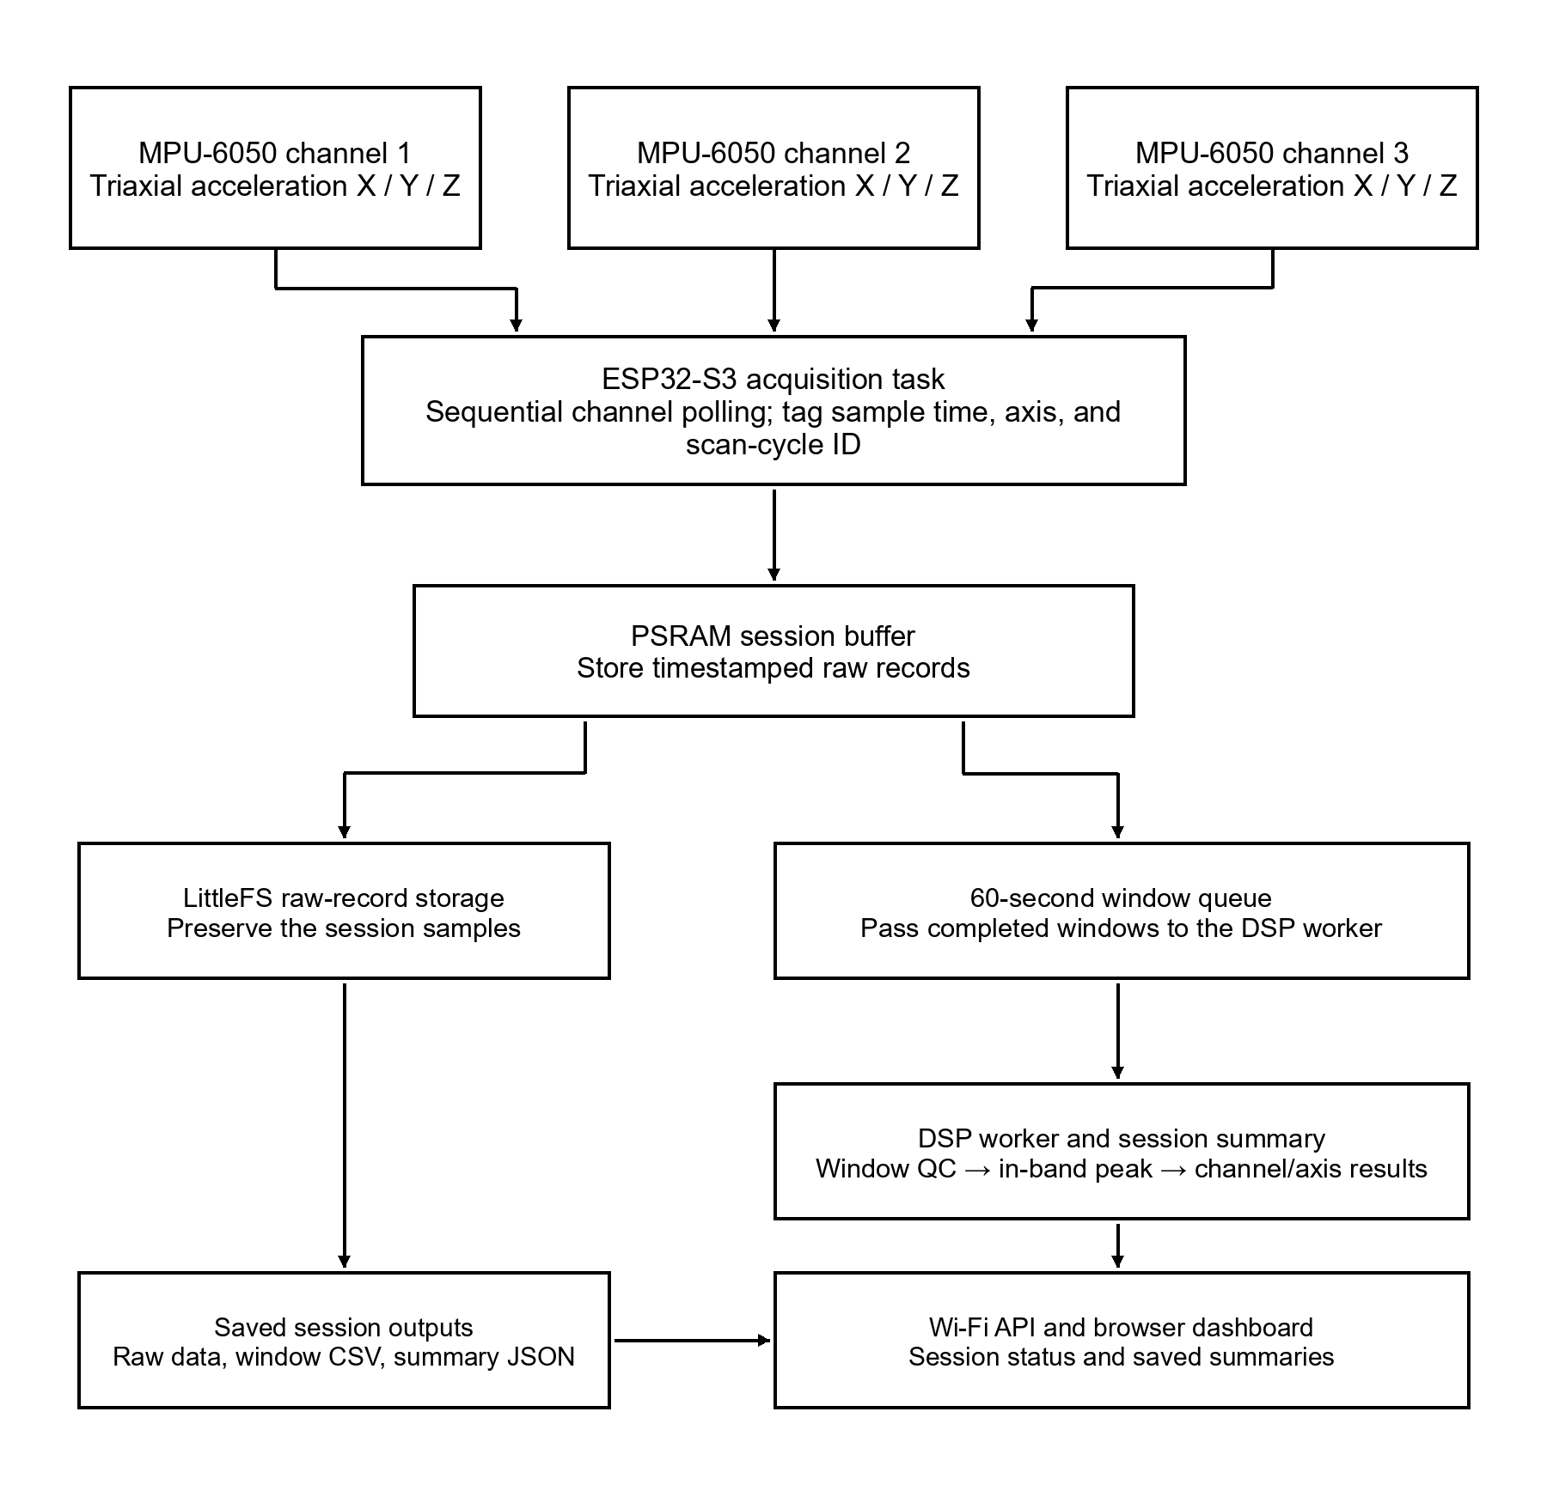
Figure 3.1. Single-Board System and Firmware Data Path
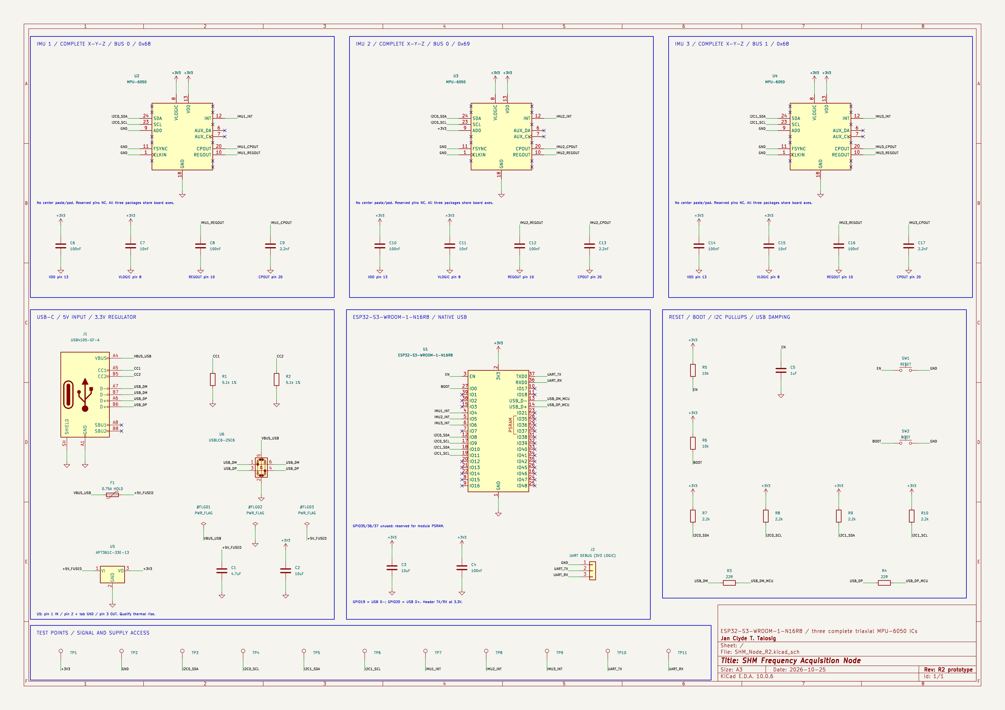
Figure 3.2. Device schematic diagram
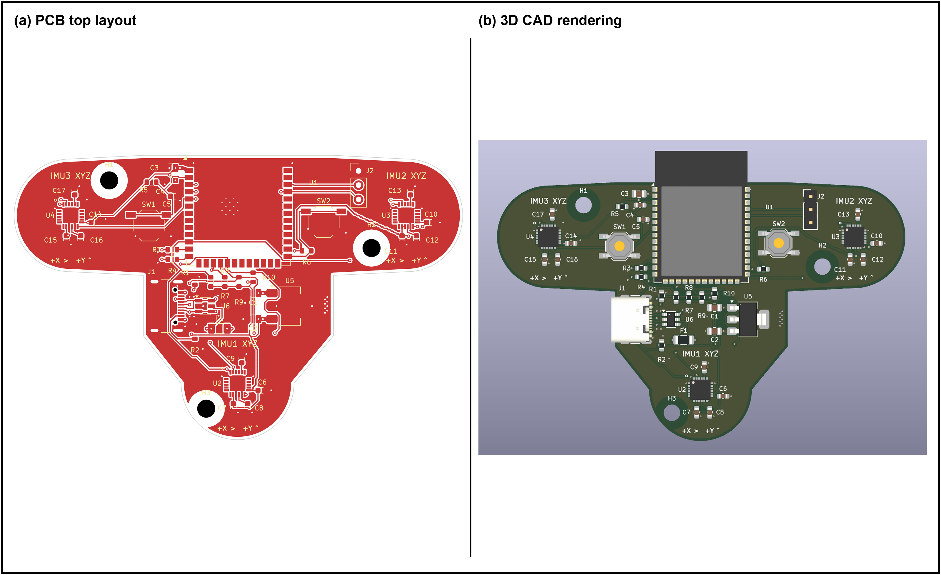
Figure 3.3. PCB layout and 3D CAD view
Figure 3.4 maps current firmware: symmetric Hann and N-point Bluestein DFT; a per-axis median requires at least 10 valid peaks. The draft specifies a pilot-selected window and median of available valid estimates. A missing axis median does not automatically invalidate the whole firmware session. Resolve this mismatch before formal collection; the diagram records implementation, not the approved method.
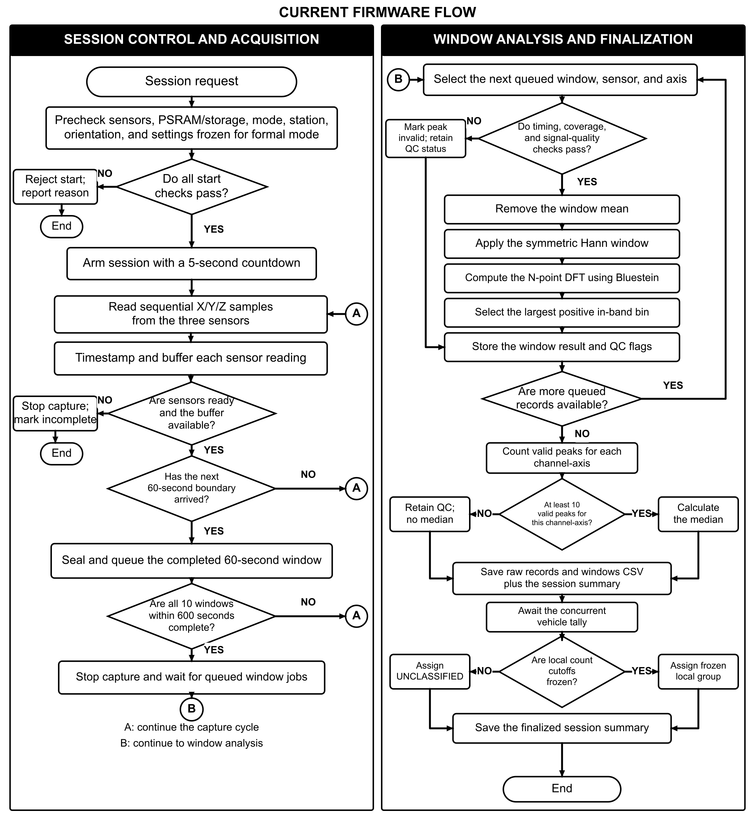
Figure 3.4. Current firmware session-control and window-processing flowchart

3.5 Field Measurement Units and Sampling Plan
For this study, the operational unit of observation is one valid 10-minute measurement session; this duration is a study-defined protocol choice, not an adequacy claim supported by prior literature. A session contains timestamped records from all three co-located IMU channels, polled in the same order at the fixed station and board orientation. The vibration stream is divided into ten consecutive 60-second analysis windows. Each channel-axis window is processed separately; the median of its valid window-level dominant-frequency estimates is retained as the session-level response. One-minute windows have been used in ambient bridge vibration analysis; their adequacy for this sensor, frequency band, and field site will be checked during the pilot (Oth & Picozzi, 2012).
The field plan targets five valid 10-minute sessions in each of the three local traffic groups—NEAR_ZERO, MEDIUM, and HEAVY. This is a practical completion target carried forward from the project plan, not a statistical power calculation or a claim of sufficient sample size (NIST/SEMATECH, n.d.-d). A session may be rejected only for predefined technical reasons such as board movement, severe clipping or saturation, corrupted data, missing timestamps, failed channel acquisition, or timing irregularity beyond the pilot-set tolerance. If a group target cannot be reached within approved field access, report the actual number of valid sessions and keep comparisons descriptive or exploratory.
Session metadata will include date, start and end time, session ID, total vehicle count and rate for the fixed 10-minute window, assigned pilot-derived group, weather and roadway-surface notes, the surveyed station and board orientation, each channel’s status, measured sampling intervals, and unusual events. For the traffic-count portion, FHWA guidance describes station, date, traffic-volume, and time-increment fields; it does not prescribe this study's 10-minute vibration-session duration or the other listed metadata (Federal Highway Administration, 2022a). The same board, station, poll order, and processing settings will be retained across sessions.
Table 2. Minimum field information recorded for each measurement session
Session field | Required information and use
Session/time | Record session ID and start/end time for the fixed 10-minute observation and vibration-acquisition period.
Traffic group | Assign NEAR_ZERO, MEDIUM, or HEAVY from the two integer cutoffs frozen after pilot work; retain the cutoff version.
Traffic count | Record the visually tallied vehicle count C and rate C/(10 min) while the board records vibration.
Environment | Record weather; add temperature/humidity when available.
Sensor/scan | Record onboard channel, station, axis, sequential scan order, timestamp, sample index, scan-cycle ID, and board orientation.
Frequency output | Record each 60-second channel-axis estimate, measured sampling rate, and N. Intended manuscript session value: median of valid window estimates; reconcile this with the firmware’s per-channel-axis 10-valid-peak gate before formal collection.

3.6 Research Instrument and Sensor Installation
The single-board monitoring unit is the primary research instrument. Before deployment, the external USB-C power path, USB programming connection, ESP32-S3, each of the three MPU-6050 channels, sequential poll order, timestamp and scan-cycle continuity, per-channel sampling intervals, raw-data recording, FFT output, and web-interface update will undergo functionality checks. The Arduino IDE firmware and library configuration will be recorded and held constant during field sessions.
The complete PCB, with all three IMU ICs co-located on the board, shall be installed at the approved roadway-deck station shown in Figure 1.2 using a mechanically stable attachment method authorized for the site. Record the single board’s location and X/Y/Z orientation; do not describe the three onboard ICs as sensors distributed across the bridge. Keep the mounting and orientation unchanged across sessions. The installation must provide stable coupling to the roadway deck while preventing movement and avoiding interference with bridge operations.
A zero-offset or static-bias check shall be conducted before each field run, and the device shall be inspected for looseness or cable movement. Where possible, a short stationary record shall be collected before acquisition to establish whether a large offset, clipping, or abnormal noise is present. These checks support repeatability but do not constitute calibration against a commercial reference instrument.

3.7 Data Gathering Procedure
Coordination with the responsible bridge authority regarding the proposed roadway-deck station, lane offset, safe work locations, attachment and traffic arrangements, and emergency procedures will be conducted before deployment. Formal data collection may begin only after written site permission, site-safety clearance, and applicable ethics and privacy determinations are in place.
- Pre-field preparation. Connect the external supply through USB-C, verify the Arduino IDE firmware and recorded library configuration, check all three onboard IMU channels, confirm the poll order and acquisition settings, synchronize the system clock, and prepare the session log and handheld vehicle counter.
- Site inspection. Verify the approved roadway-deck station against the site sketch, identify safe positions for the board operator and the separate traffic observer, document roadway-surface and environmental conditions, and confirm the authorized attachment procedure.
- Board installation. Attach the single PCB securely at the approved roadway-deck station, record its location and orientation, and verify that the three onboard IMU axes match the stated analysis directions.
- Stationary check. Record a short stationary segment from each sensor and verify that the data are free from obvious saturation, discontinuity, abnormal noise, or missing samples before the session.
- Concurrent traffic observation. During the same fixed 10-minute session, a separate observer at a safe viewpoint visually counts vehicles crossing the selected reference point with a handheld tally counter. Record the start/end time and total count; assign the session’s traffic group only after applying the pilot cutoffs frozen before formal collection.
- Vibration acquisition. Record for exactly 600 seconds while polling channel 1 X/Y/Z, channel 2 X/Y/Z, and channel 3 X/Y/Z sequentially. Timestamp and tag each reading. Divide the acquisition into ten consecutive 60-second analysis windows; do not extend a session to reach a target vehicle count or change the station, board orientation, scan order, or software settings.
- Session closure. Stop the vehicle tally and vibration acquisition together at 600 seconds. Save the raw timestamped records, channel and axis identifiers, sample indices, scan-cycle IDs, total vehicle count, count rate, traffic group, field-log metadata, and valid window-level frequency outputs. Inspect the record against the predefined technical acceptance criteria and log any exclusion reason.
- Repetition. Continue with the same fixed protocol until the practical target of five valid sessions has been reached in each pilot-defined traffic group, subject to approved site access. If a group remains short, retain and report the actual count; do not change the vehicle cutoffs after reviewing frequency results.
Table 3. Vibration-acquisition protocol summary
Item | Proposed protocol and verification status
Vibration acquisition | Record for exactly 600 seconds while polling X/Y/Z from channels 1, 2, and 3 sequentially. Timestamp and tag every reading. Divide the record into ten consecutive 60-second windows. Do not extend the session or change the station, board orientation, scan order, or software settings.
Concurrent traffic tally | A separate observer tallies vehicles during the same 600 seconds at the approved reference point from a safe viewpoint.
Sensor arrangement | One PCB at one fixed station; three co-located MPU-6050 channels. Record the board location and orientation.
Window timing and quality | Check measured per-channel timing, record completeness, clipping, and timing criteria for every 60-second window.
Window function | The manuscript says pilot-selected; current firmware uses a symmetric Hann window. Resolve and freeze the setting before formal collection.
Session summary | The manuscript proposes the median of valid window estimates; current firmware emits a per-channel-axis median only when that stream has at least 10 valid peaks. This gate does not by itself invalidate all session data. Align the approved method and firmware before formal data collection.
Close and retain | Stop the tally and acquisition together at 600 seconds. Retain raw records, metadata, window outputs, quality status, and any exclusion reason.

3.8 Traffic-Condition Characterization
Traffic condition is represented by the total number of vehicles crossing the fixed reference point during each 10-minute session. FHWA’s 2022 Traffic Monitoring Guide lists 10-minute data as one possible increment in a specific continuous-count-station AADT calculation procedure; its 2013 guide describes typical short-duration roadway-monitoring counts as 24 hours, 48 hours, or one week. The 10-minute interval used here pairs a concurrent vehicle count with one vibration session; it is not an AADT estimate or a standard representative short-duration traffic count (Federal Highway Administration [FHWA], 2013, 2022b). During a pilot, record equal-duration counts across the field periods expected to be sampled. Let m be the number of pilot sessions, and order their vehicle counts from smallest to largest. Define the two nearest-rank empirical tertile cutoffs as shown below. The exact integer cutoffs cannot be supplied until local pilot observations exist.
$$c_{1} = C_{(⌈m/3⌉)}, c_{2} = C_{(⌈2m/3⌉)}$$
For each fixed 10-minute session, let C be the number of vehicles counted. The observed rate is r = C/T = C/10 vehicles per minute, where T = 10 minutes. Retain C, r, and the assigned local group in the session log. These labels describe traffic volume only; they are not civil-engineering load classes or calibrated measures of structural excitation.
Classify a session as NEAR_ZERO when its count C is at or below the lower cutoff c1, MEDIUM when c1 < C ≤ c2, and HEAVY when C exceeds the upper cutoff c2. NEAR_ZERO means the lowest pilot-observed local count band and may include nonzero counts. If ties make the cutoffs equal or leave a group empty, repeat or adjust the pilot plan and freeze revised cutoffs before collecting formal sessions. Keep the assigned label, count, and rate in the session record; never reclassify after looking at frequency outcomes.
Table 4. Pilot-derived traffic-group rules
Measure/group | Rule | Interpretation and required record
Count and rate | C = vehicles counted in the fixed 10-minute session; T = 10 minutes; r = C/T = C/10 vehicles per minute. | Retain C, r, and the assigned local group in the session log; these are traffic-volume descriptors.
NEAR_ZERO | C ≤ c1 | Lowest pilot-observed local count band; it may include nonzero counts.
MEDIUM | c1 < C ≤ c2 | Middle pilot-observed local count band.
HEAVY | C > c2 | Highest pilot-observed local count band; not a vehicle-weight or engineering load class.
Cutoffs and safeguards | c1 and c2 are nearest-rank pilot tertiles; numeric values remain pending local pilot counts. | Freeze cutoffs before formal collection. If ties make a cutoff equal or leave a group empty, revise the pilot plan and freeze new cutoffs before formal sessions. Never reclassify after reviewing frequency outcomes.
The traffic labels are descriptive local groupings, not civil-engineering traffic classes, vehicle-weight estimates, or calibrated measures of structural excitation. FHWA describes manual counts as visual observations recorded on a tally sheet or electronic counter; use a handheld counter and a safe observation position. If the pilot shows that simultaneous traffic cannot be counted reliably from one viewpoint, document the limitation and revise the observer arrangement before formal sessions (FHWA, 2013).
The analysis uses all three planned traffic groups. If a group lacks valid sessions or distinct pilot cutoffs, report that limitation and keep results descriptive or exploratory. Do not stop an individual session when it reaches a vehicle-count target; the timer controls its duration, while the pilot-frozen count cutoffs determine the group.

3.9 Signal Processing and Dominant-Frequency Extraction
Process each accepted 60-second analysis window separately for every onboard channel-axis. Treat its timestamped samples as a uniformly spaced sequence only when the measured timing tolerance is satisfied; remove the window mean, apply the fixed pilot-selected window function, compute the DFT using an FFT, and form the magnitude spectrum. Exclude the zero-frequency bin and select the largest-magnitude bin inside the fixed analysis band. Do not interleave channel records. Apply the same window duration, analysis band, and peak-selection rule to every session.
The Fast Fourier Transform computes the Discrete Fourier Transform efficiently. For each uniformly sampled channel-axis record with measured sampling frequency f_s and N samples, the frequency-bin spacing is given in Equation (1). For a 60-second record with uniform timing, the nominal spacing is 1/60 Hz, approximately 0.0167 Hz; the actual sample rate, N, timing tolerance, and resulting resolution will be checked during the pilot. Use each channel’s measured sampling frequency rather than the overall three-channel scan rate.

$$∆f=\frac{f_{s}}{N}$$ | (1)

Here, $Δf$ is the frequency-bin spacing in hertz, $f_{s}$ is the per-channel sampling frequency in hertz, and N is the number of samples in one analysis window. Each FFT input covers 60 seconds; the pilot will verify that timestamp-derived sampling and N yield the required frequency resolution within ESP32-S3 processing and memory limits. The analyzed frequency range will not exceed the Nyquist frequency $\frac{f_{s}}{2}$.
For the mean-removed and windowed sequence, the complex DFT is:
$$X\left[k\right]= \sum_{n=0}^{N-1}{w\left[n\right]\left(x\left[n\right]- \bar{x}\right)e^{-\frac{j2πkn}{N}}}$$
$$f_{k}=k\left( \frac{f_{s}}{N} \right)$$ | (2)

For real-valued acceleration data, retain the positive-frequency bins up to the highest bin at or below the Nyquist frequency, excluding zero frequency. Restrict selection to the fixed analysis band $0 < f_{\min{}}≤ f_{k}≤ f_{\max{}}≤\frac{f_{s}}{2}$. Within that band, select the bin with the greatest magnitude. The selected bin index is $k^{*}$. The dominant-frequency estimate is then $f_{d}=\frac{k^{*}f_{s}}{N}$; no sub-bin interpolation is applied. The same per-sensor-axis band and selection rule will be used for every session.
Peak picking is computationally lightweight and is suitable for a constrained embedded implementation when the dominant peaks are sufficiently separated. However, because peak picking can be ambiguous for closely spaced modes or weak/noisy responses, the result is treated primarily as a repeatable dominant spectral-frequency indicator. It is not automatically assumed to represent every theoretical natural frequency or a unique structural mode (Hasani & Freddi, 2023).
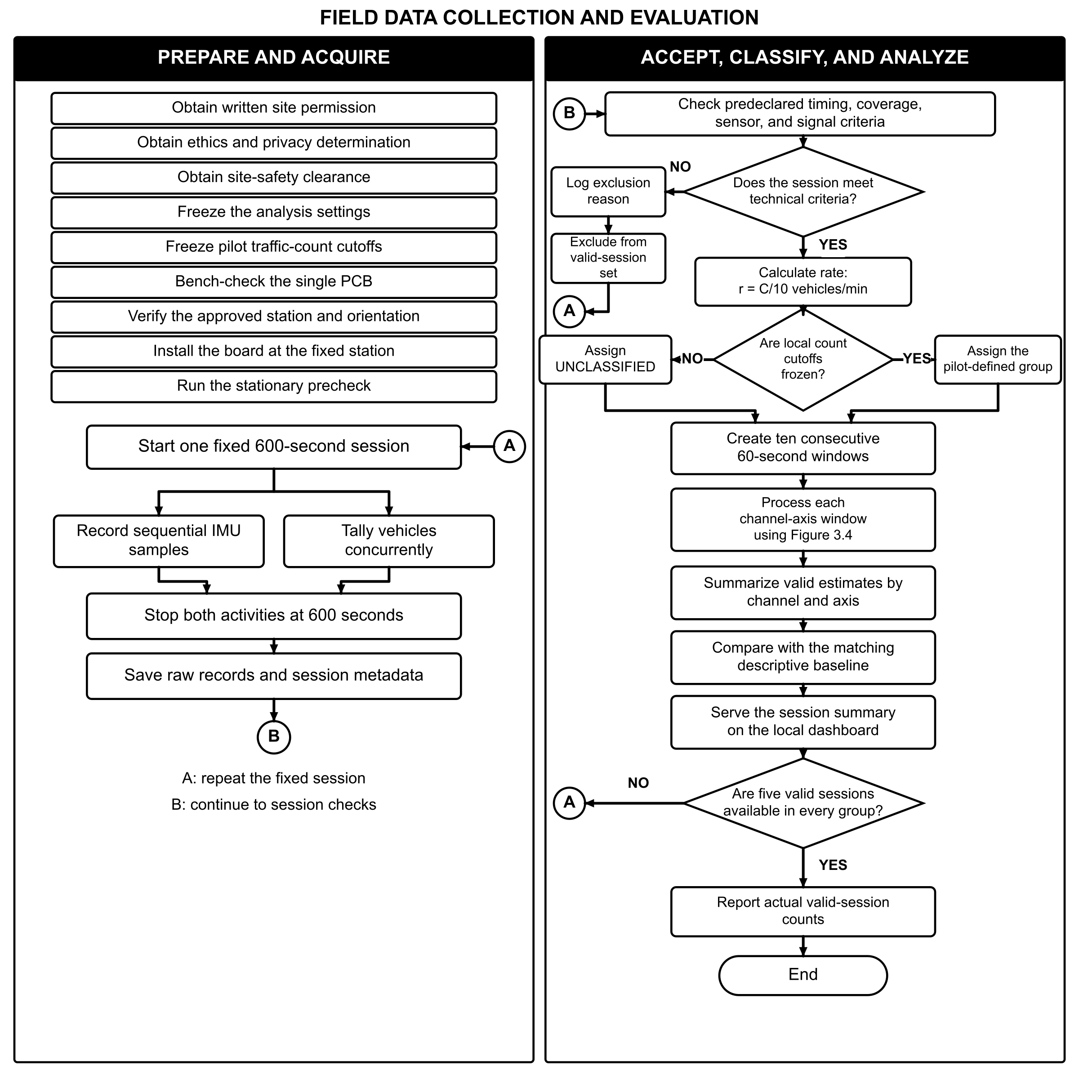
Figure 3.5. Field Data Collection and Evaluation Flowchart

3.10 Baseline Frequency Construction
For each traffic group, onboard channel, and axis, construct the baseline from valid session-level estimates, where each session estimate is the median of its valid 60-second window estimates. The baseline is internal to this device, one roadway-deck station, and study period; it is not an accepted safety limit or an externally validated reference.
For one traffic-category, sensor, and axis stratum, let $f_{i}$ denote the dominant-frequency estimate from valid session i, with $n ≥ 2$ sessions. The sample mean and sample standard deviation are calculated as follows (NIST/SEMATECH, n.d.-a):
$$\bar{x}=\frac{\sum_{i=1}^{n}{f_{i}}}{n}$$
$$s = \sqrt{\frac{\sum_{i=1}^{n{\left(f_{i}- \bar{x}\right)}^{2}}{}}{n - 1}}$$
$$Baseline interval=\bar{x}±s$$ | (3)
Here, $\bar{x}$ is the mean dominant-frequency estimate and $s$ is the sample standard deviation within that traffic-category, sensor, and axis stratum. The descriptive baseline interval is shown in Equation (3). The coefficient of variation is also reported to describe relative dispersion:
$$CV=\left( \frac{s}{\bar{x}} \right)×100\%$$ | (4)
The interval in Equation (3) describes the observed one-standard-deviation spread across session-level estimates. A separate configurable review band is $\bar{x}± k_{\left(review\right)s}$, with $k_{review}= 2$ as the default. Values outside this band are flagged for review only. The default two-standard-deviation review band is a project heuristic, not a 95% confidence or prediction interval, structural-safety limit, or damage threshold; formal prediction limits depend on sample size and a specified statistical model (NIST/SEMATECH, n.d.-c). The results will report session-level n, traffic cutoffs and counts, channel/axis identity, and the chosen review multiplier for every baseline.

Statistical Treatment
Descriptive statistics will summarize the session-level dominant-frequency estimates separately for each traffic category, sensor, and axis. Report valid session count n, mean, sample standard deviation, minimum, maximum, and coefficient of variation. Sensor and axis readings collected within one session are linked measurements and will not be counted as independent session replicates.
The primary analysis is descriptive. For each traffic group, onboard channel, and axis, report session-level n, mean, median, sample standard deviation, minimum, maximum, and coefficient of variation. The five-session-per-group target is a practical completion target, not evidence of adequate statistical power or sample size. Before any confirmatory category comparison, calculate and document the required sample size using a prespecified effect of interest, significance level, desired power, and a defensible variance estimate. NIST/SEMATECH notes that sample-size requirements depend on significance level, power, and population variation (NIST/SEMATECH, n.d.-d). If the available sample is not supported by that calculation, treat category differences as exploratory and do not claim confirmatory significance. For a justified inferential comparison, set the significance level at $α = 0.05$; any post-hoc comparison will be selected and reported with the actual sample sizes and assumptions (NIST/SEMATECH, n.d.-b).
If the prespecified sample-size analysis supports an inferential comparison, use one-way ANOVA separately for each channel-axis response only when observations are independent and its assumptions are reasonably supported. Examine residual behavior and equality of variances using suitable diagnostics; consider diagnostic plots, group sizes, outliers, and measurement context rather than interpreting a normality test alone. If ANOVA assumptions are not reasonably supported, use Kruskal–Wallis only when category samples are independent. Report actual sample sizes and the basis for the selected analysis.
The three traffic categories are analyzed separately for each sensor-axis; results from different sensors or axes are not pooled as independent observations. If session independence or sample size does not support an inferential comparison, report descriptive results and treat between-category differences as exploratory.

Reliability and Repeatability Assessment
System performance will be assessed using measures available from the prototype and field logs: session completion and validity; the percentage of required samples/windows present for each channel-axis; measured per-channel sampling interval and timing variability; agreement between the embedded FFT result and an independent offline FFT applied to the same raw window; repeatability of session-level frequency estimates; and successful dashboard/session-log updates. These checks evaluate acquisition and processing performance. Without a calibrated reference accelerometer, they do not establish absolute acceleration or frequency accuracy.
For DSP verification, feed a generated test signal with a known frequency through the same FFT peak-selection settings and verify that the returned bin follows the expected frequency-bin spacing. For field-data comparison, independently recompute the FFT from the exact recorded sample window and compare the selected bin with the firmware output. Under similar mounting and traffic-count conditions, compare repeated session-level medians using the mean, sample standard deviation, and coefficient of variation. Log board revisions, remounting, firmware, sampling, and processing changes; do not present repeatability as calibration accuracy.

Data Quality Control and Acceptance Criteria
Admit a session only when the board remained fixed at the approved station, all three onboard IMU channels have complete timestamped records for the required 10-minute session, the fixed scan order and timing tolerance are met, the ten 60-second windows and metadata are present, and the signals are suitable for the predefined FFT procedure. Exclude sessions with saturation, severe clipping, unrecoverable missing or irregular samples, corrupted files, or documented hardware failure, and record the reason in a data-quality log.
The researchers shall avoid selective removal of observations merely because their frequencies are unusually high or low. Outliers will first be investigated for technical causes. If no technical cause is identified, the observation shall remain in the dataset and be addressed through transparent statistical analysis. This procedure reduces the risk of manipulating the baseline to obtain a desired result.

Ethical, Safety, and Site Considerations
The study involves field work on an active bridge and therefore requires safety procedures beyond those applicable to laboratory testing. Written authorization from the responsible authority shall be obtained before formal deployment. Researchers shall remain in designated safe areas, use appropriate personal protective equipment, secure cables and hardware against movement, and avoid any activity that could distract drivers, obstruct traffic, or compromise bridge operations.
The study will not intentionally impose abnormal or unsafe loads on the bridge; vehicle activity will be observed as it occurs during normal operation. No personally identifying information from drivers or pedestrians is required for the vibration-frequency analysis. The current firmware requires an operator-name field and writes it to session metadata. Before data collection, the project must determine whether to remove this field or use a coded identifier and define who may access the records, how long they are retained, and how they are deleted, subject to the responsible institution’s review. If photographs or field videos are collected for documentation, they shall be limited to what is necessary for the methodology and shall avoid unnecessary identification of individuals.

Summary of the Methodological Framework
The methodology links vibration response at one fixed roadway-deck station to system output through repeated 10-minute sessions. One PCB carries three co-located triaxial IMUs. Firmware polls channel 1 X/Y/Z, channel 2 X/Y/Z, and channel 3 X/Y/Z sequentially; a separate observer tallies vehicle passages during the same 600 seconds. Each session contains ten 60-second analysis windows. Each valid window is processed separately, and the median valid window estimate gives the session-level result for each channel-axis. Pilot-frozen vehicle-count cutoffs assign the local traffic label. Baselines use independent session-level estimates; x-bar plus/minus s describes spread and a separate default two-s band prompts review only. The system evaluation covers record completeness, timing, DSP agreement, repeatability, and dashboard output; it does not diagnose damage or assess safety.
This methodology is intentionally limited to frequency characterization of roadway-deck vibration at the documented station and system evaluation. It does not establish a structural damage threshold, diagnose a specific defect, determine load capacity, or replace formal bridge inspection. These boundaries preserve consistency between the methods, the stated objectives, and the scope of the study.

CHAPTER IV

RESULTS AND DISCUSSION
This chapter is reserved for system acquisition and processing performance and per-channel, per-axis frequency results by pilot-defined traffic group. This proposal-stage draft contains no measured field findings.

4.1 Introduction
After approved data collection, this section will summarize valid-session counts and exclusions and introduce the system-performance and roadway-deck frequency results.

4.2 System Acquisition and Processing Performance
System-evaluation results will include session completion and validity, channel-axis sample completeness, measured scan timing, embedded-versus-offline FFT agreement, repeatability, and dashboard/session-log updates, based on completed bench and field records.

4.3 Roadway-Deck Frequency by Traffic-Count Group
Frequency results will be summarized by the pilot-frozen NEAR_ZERO, MEDIUM, and HEAVY groups, onboard channel, and axis, with observed vehicle counts and sample sizes. Group differences will be treated as exploratory unless a prespecified sample-size calculation supports inference. These results do not constitute a damage diagnosis or safety determination.

CHAPTER V

CONCLUSION AND RECOMMENDATIONS
This chapter will summarize completed procedures and findings and state conclusions and recommendations supported by collected data. It remains to be completed after field collection and analysis.

5.1 Summary
The summary will be completed after field collection and will include the finalized study purpose, approved station, confirmed hardware and software configuration, valid-session counts, and principal descriptive results from the actual study record.

5.2 Conclusion
Conclusions will be drawn from completed results and will address each research objective. They will not claim structural damage diagnosis or bridge-safety assessment.

5.3 Recommendations
Recommendations will follow from the completed evaluation results and may identify development changes or further validation supported by the analysis.

REFERENCES

Ali, A., Sandhu, T. Y., & Usman, M. (2019). Ambient vibration testing of a pedestrian bridge using low-cost accelerometers for SHM applications. Smart Cities, 2(1), 20–30. https://doi.org/10.3390/smartcities2010002
Avci, O., Abdeljaber, O., Kiranyaz, S., Hussein, M., & Inman, D. J. (2021). A review of vibration-based damage detection in civil structures: From traditional methods to machine learning and deep learning applications. Mechanical Systems and Signal Processing, 147, 107077. https://doi.org/10.1016/j.ymssp.2020.107077
Azhar, A. S., Abdul Kudus, S., Jamadin, A., Mustaffa, N. K., & Sugiura, K. (2024). Recent vibration-based structural health monitoring on steel bridges: Systematic literature review. Ain Shams Engineering Journal, 15(3), 102501. https://doi.org/10.1016/j.asej.2023.102501
Baccay, O. T. (2025, November 13). Buntun Bridge: The steel giant of Cagayan’s lifeline. Philippine Information Agency. https://pia.gov.ph/features/buntun-bridge-the-steel-giant-of-cagayans-lifeline/
Bendat, J. S., & Piersol, A. G. (2011). Random data: Analysis and measurement procedures (4th ed.). Wiley.
Brincker, R., Ventura, C. E., & Andersen, P. (2001). Damping estimation by frequency domain decomposition. In Proceedings of IMAC 19: A Conference on Structural Dynamics (pp. 698–703). Society for Experimental Mechanics. https://vbn.aau.dk/ws/files/12773740/Damping_Estimation_by_Frequency_Domain_Decomposition
Brincker, R., Zhang, L. M., & Andersen, P. (2001). Modal identification of output-only systems using frequency domain decomposition. Smart Materials and Structures, 10(3), 441–445. https://doi.org/10.1088/0964-1726/10/3/303
Brownjohn, J. M. W. (2007). Structural health monitoring of civil infrastructure. Philosophical Transactions of the Royal Society A: Mathematical, Physical and Engineering Sciences, 365(1851), 589–622. https://doi.org/10.1098/rsta.2006.1925
Camara, A., Vazquez, V. F., Ruiz-Teran, A. M., & Paje, S. E. (2017). Influence of the pavement surface on the vibrations induced by heavy traffic in road bridges. Canadian Journal of Civil Engineering, 44(12), 1099–1111. https://doi.org/10.1139/cjce-2017-0310
Cantero, D., Hester, D., & Brownjohn, J. (2017). Evolution of bridge frequencies and modes of vibration during truck passage. Engineering Structures, 152, 452–464. https://doi.org/10.1016/j.engstruct.2017.09.039
Cantero, D., McGetrick, P., Kim, C.-W., & O’Brien, E. (2019). Experimental monitoring of bridge frequency evolution during the passage of vehicles with different suspension properties. Engineering Structures, 187, 209–219. https://doi.org/10.1016/j.engstruct.2019.02.065
Carden, E. P., & Fanning, P. (2004). Vibration based condition monitoring: A review. Structural Health Monitoring, 3(4), 355–377. https://doi.org/10.1177/1475921704047500
Chang, K.-C., Kim, C.-W., & Borjigin, S. (2014). Variability in bridge frequency induced by a parked vehicle. Smart Structures and Systems, 13(5), 755–773. https://doi.org/10.12989/sss.2014.13.5.755
Chaudhari, R. S., Nama, S., Narkhede, M. M., Bhangale, V. P., Gaikwad, R. B., & More, M. M. (2026). Next generation vibration-based structural health monitoring for bridges: A systematic review of AI, IoT, and digital twin integrations. Journal of Building Pathology and Rehabilitation, 11, 136. https://doi.org/10.1007/s41024-026-00810-0
Chen, G.-W., Omenzetter, P., & Beskhyroun, S. (2017). Operational modal analysis of an eleven-span concrete bridge subjected to weak ambient excitations. Engineering Structures, 151, 839–860. https://doi.org/10.1016/j.engstruct.2017.08.066
Cooley, J. W., & Tukey, J. W. (1965). An algorithm for the machine calculation of complex Fourier series. Mathematics of Computation, 19(90), 297–301. https://www.jstor.org/stable/2003354
Cornwell, P., Farrar, C. R., Doebling, S. W., & Sohn, H. (1999). Environmental variability of modal properties. Experimental Techniques, 23(6), 45–48. https://doi.org/10.1111/j.1747-1567.1999.tb01320.x
Cross, E. J., Koo, K. Y., Brownjohn, J. M. W., & Worden, K. (2013). Long-term monitoring and data analysis of the Tamar Bridge. Mechanical Systems and Signal Processing, 35(1–2), 16–34. https://doi.org/10.1016/j.ymssp.2012.08.026
Cunha, A., Caetano, E., & Delgado, R. (2001). Dynamic tests on large cable-stayed bridge. Journal of Bridge Engineering, 6(1), 54–62. https://doi.org/10.1061/(ASCE)1084-0702(2001)6:1(54)
Das, S., Saha, P., & Patro, S. K. (2016). Vibration-based damage detection techniques used for health monitoring of structures: A review. Journal of Civil Structural Health Monitoring, 6, 477–507. https://doi.org/10.1007/s13349-016-0168-5
Deng, Z., Huang, M., Wan, N., & Zhang, J. (2023). The current development of structural health monitoring for bridges: A review. Buildings, 13(6), 1360. https://doi.org/10.3390/buildings13061360
Department of Social Welfare and Development. (2025, March 1). DROMIC report #1 on the collapsed bridge in Brgy. Casibarag Norte, Cabagan, Isabela as of 01 March 2025, 6:00 PM [Report]. https://dromic.dswd.gov.ph/wp-content/uploads/2025/03/DSWD-DROMIC-Report-1-on-the-Collapsed-Bridge-in-Brgy.-Casibarag-Norte-Cabagan-Isabela-as-of-01-March-2025-6PM.pdf
Deraemaeker, A., Reynders, E., De Roeck, G., & Kullaa, J. (2008). Vibration-based structural health monitoring using output-only measurements under changing environment. Mechanical Systems and Signal Processing, 22(1), 34–56. https://doi.org/10.1016/j.ymssp.2007.07.004
Doebling, S. W., Farrar, C. R., & Prime, M. B. (1998). A summary review of vibration-based damage identification methods. The Shock and Vibration Digest, 30(2), 91–105. https://doi.org/10.1177/058310249803000201
Doebling, S. W., Farrar, C. R., Prime, M. B., & Shevitz, D. W. (1996). Damage identification and health monitoring of structural and mechanical systems from changes in their vibration characteristics: A literature review (LA-13070-MS). Los Alamos National Laboratory. https://pmc.ncbi.nlm.nih.gov/articles/PMC10856960
El Dahr, R., Lignos, X., Papavieros, S., & Vayas, I. (2022). Design and validation of an accurate low-cost data acquisition system for structural health monitoring of a pedestrian bridge. Journal of Civil Engineering and Construction, 11(3), 113–126. https://doi.org/10.32732/jcec.2022.11.3.113
Emadi, S., Komarizadehasl, S., & Xia, Y. (2025). Application of intelligent low-cost accelerometers for bridge monitoring with a deep learning approach. Structural Control and Health Monitoring, 2025, Article 9835353. https://doi.org/10.1155/stc/9835353
Espressif Systems. (2026). ESP32-S3-WROOM-1 & WROOM-1U datasheet (Version 1.8). https://documentation.espressif.com/esp32-s3-wroom-1_wroom-1u_datasheet_en.html
Espressif Systems. (n.d.). Establish serial connection with ESP32-S3. ESP-IDF Programming Guide. https://docs.espressif.com/projects/esp-idf/en/latest/esp32s3/get-started/establish-serial-connection.html
Fan, W., & Qiao, P. (2011). Vibration-based damage identification methods: A review and comparative study. Structural Health Monitoring, 10(1), 83–111. https://doi.org/10.1177/1475921710365419
Farrar, C. R., & Lieven, N. A. J. (2007). Damage prognosis: The future of structural health monitoring. Philosophical Transactions of the Royal Society A: Mathematical, Physical and Engineering Sciences, 365(1851), 623–632. https://doi.org/10.1098/rsta.2006.1927
Farrar, C. R., & Worden, K. (2007). An introduction to structural health monitoring. Philosophical Transactions of the Royal Society A: Mathematical, Physical and Engineering Sciences, 365(1851), 303–315. https://doi.org/10.1098/rsta.2006.1928
Federal Highway Administration. (2013). Traffic Monitoring Guide: Traffic monitoring theory. U.S. Department of Transportation. https://www.fhwa.dot.gov/policyinformation/tmguide/tmg_2013/traffic-monitoring-theory.cfm
Federal Highway Administration. (2022a). Traffic Monitoring Guide: Traffic data formats. U.S. Department of Transportation. https://www.fhwa.dot.gov/policyinformation/tmguide/tmg_2022/traffic-data-formats.cfm
Federal Highway Administration. (2022b). Traffic Monitoring Guide: Traffic data methodologies. U.S. Department of Transportation. https://www.fhwa.dot.gov/policyinformation/tmguide/tmg_2022/traffic-data-methodologies.cfm
Furtmüller, T., Adam, C., & Veit-Egerer, R. (2022). Variable mass loading effect on the long-term ambient response of a freeway bridge. Structure and Infrastructure Engineering, 18(3), 330–344. https://doi.org/10.1080/15732479.2020.1849321
Gaviña, J. A. R., Uy, F. A. A., & Carreon, J. P. D. (2017). Wireless smart sensor network system using SmartBridge sensor nodes for structural health monitoring of existing concrete bridges. IOP Conference Series: Materials Science and Engineering, 216, 012050. https://doi.org/10.1088/1757-899X/216/1/012050
Giermann, S., Willemsen, T., & Blankenbach, J. (2025). Structural monitoring without a budget—Laboratory results and field report on the use of low-cost acceleration sensors. Sensors, 25(15), 4543. https://doi.org/10.3390/s25154543
Górski, P., Napieraj, M., & Konopka, E. (2020). Variability evaluation of dynamic characteristics of highway steel bridge based on daily traffic-induced vibrations. Measurement, 164, 108074. https://doi.org/10.1016/j.measurement.2020.108074
Harris, F. J. (1978). On the use of windows for harmonic analysis with the discrete Fourier transform. Proceedings of the IEEE, 66(1), 51–83. https://doi.org/10.1109/PROC.1978.10837
Hasani, H., & Freddi, F. (2023). Operational modal analysis on bridges: A comprehensive review. Infrastructures, 8(12), 172. https://doi.org/10.3390/infrastructures8120172
Hasani, H., Freddi, F., Piazza, R., & Ceruffi, F. (2024). A wireless data acquisition system based on MEMS accelerometers for operational modal analysis of bridges. Sensors, 24(7), 2121. https://doi.org/10.3390/s24072121
Hidalgo-Fort, E., Blanco-Carmona, P., Muñoz-Chavero, F., Torralba, A., & Castro-Triguero, R. (2024). Low-cost, low-power edge computing system for structural health monitoring in an IoT framework. Sensors, 24(15), 5078. https://doi.org/10.3390/s24155078
International Organization for Standardization. (2003). ISO 16063-21:2003: Methods for the calibration of vibration and shock transducers—Part 21: Vibration calibration by comparison to a reference transducer. https://www.iso.org/standard/27053.html
International Organization for Standardization. (2021). ISO 5348:2021: Mechanical vibration and shock—Mechanical mounting of accelerometers. https://www.iso.org/standard/78160.html
InvenSense Inc. (2013). MPU-6000/MPU-6050 product specification (Revision 3.4). https://product.tdk.com/system/files/dam/doc/product/sensor/mortion-inertial/imu/data_sheet/mpu-6000-datasheet1.pdf
Kim, C. Y., Jung, D. S., Kim, N. S., Kwon, S. D., & Feng, M. Q. (2003). Effect of vehicle weight on natural frequencies of bridges measured from traffic-induced vibration. Earthquake Engineering and Engineering Vibration, 2(1), 109–115. https://doi.org/10.1007/BF02857543
Ko, J. M., & Ni, Y. Q. (2005). Technology developments in structural health monitoring of large-scale bridges. Engineering Structures, 27(12), 1715–1725. https://doi.org/10.1016/j.engstruct.2005.02.021
Komarizadehasl, S., Huguenet, P., Lozano, F., Lozano-Galant, J. A., & Turmo, J. (2022b). Operational and analytical modal analysis of a bridge using low-cost wireless Arduino-based accelerometers. Sensors, 22(24), 9808. https://doi.org/10.3390/s22249808
Komarizadehasl, S., Lozano, F., Lozano-Galant, J. A., Ramos, G., & Turmo, J. (2022a). Low-cost wireless structural health monitoring of bridges. Sensors, 22(15), 5725. https://doi.org/10.3390/s22155725
Komarizadehasl, S., Xia, Y., Komary, M., & Lozano, F. (2024). Eigenfrequency analysis of bridges using a smartphone and a novel low-cost accelerometer prototype. Frontiers of Structural and Civil Engineering, 18(2), 202–215. https://doi.org/10.1007/s11709-024-1055-5
Koo, K. Y., Brownjohn, J. M. W., List, D. I., & Cole, R. (2013). Structural health monitoring of the Tamar suspension bridge. Structural Control and Health Monitoring, 20(4), 609–625. https://doi.org/10.1002/stc.1481
Kullaa, J. (2011). Distinguishing between sensor fault, structural damage, and environmental or operational effects in structural health monitoring. Mechanical Systems and Signal Processing, 25(8), 2976–2989. https://doi.org/10.1016/j.ymssp.2011.05.017
Lau, J. V. J., Bassig, C. A. M. L., Celino, E. J. C., & Carreon, J. P. D. (2018). Fuzzy based bridge structural health rating of existing bridges using accelerometer sensors: Case of Zamora Bridge. MATEC Web of Conferences, 206, 01013. https://doi.org/10.1051/matecconf/201820601013
Li, J., Su, M., & Fan, L. (2003). Natural frequency of railway girder bridges under vehicle loads. Journal of Bridge Engineering, 8(4), 199–203. https://doi.org/10.1061/(ASCE)1084-0702(2003)8:4(199)
Lynch, J. P. (2007). An overview of wireless structural health monitoring for civil structures. Philosophical Transactions of the Royal Society A: Mathematical, Physical and Engineering Sciences, 365(1851), 345–372. https://doi.org/10.1098/rsta.2006.1932
Lynch, J. P., & Loh, K. J. (2006). A summary review of wireless sensors and sensor networks for structural health monitoring. The Shock and Vibration Digest, 38(2), 91–128. https://doi.org/10.1177/0583102406061499
Lynch, J. P., Sundararajan, A., Law, K. H., Kiremidjian, A. S., Carryer, E., Sohn, H., & Farrar, C. R. (2003). Field validation of a wireless structural monitoring system on the Alamosa Canyon Bridge. Proceedings of SPIE, 5057, 267–278. https://doi.org/10.1117/12.482712
Magalhães, F., Caetano, E., & Cunha, A. (2007). Challenges in the application of stochastic modal identification methods to a cable-stayed bridge. Journal of Bridge Engineering, 12(6), 746–754. https://doi.org/10.1061/(ASCE)1084-0702(2007)12:6(746)
Magalhães, F., Cunha, A., & Caetano, E. (2009). Online automatic identification of the modal parameters of a long span arch bridge. Mechanical Systems and Signal Processing, 23(2), 316–329. https://doi.org/10.1016/j.ymssp.2008.05.003
Magalhães, F., Cunha, A., & Caetano, E. (2012). Vibration-based structural health monitoring of an arch bridge: From automated OMA to damage detection. Mechanical Systems and Signal Processing, 28, 212–228. https://doi.org/10.1016/j.ymssp.2011.06.011
Meng, D., Xiao, F., Zhang, L., Xu, X., Chen, G. S., Zatar, W., & Hulsey, J. L. (2019). Nonlinear vibration analysis of vehicle–bridge interaction for condition monitoring. Journal of Low Frequency Noise, Vibration and Active Control, 38(3–4), 1422–1432. https://doi.org/10.1177/1461348418811703
Moravvej, M., & El-Badry, M. (2024). Reference-free vibration-based damage identification techniques for bridge structural health monitoring—A critical review and perspective. Sensors, 24(3), 876. https://doi.org/10.3390/s24030876
Moser, P., & Moaveni, B. (2011). Environmental effects on the identified natural frequencies of the Dowling Hall Footbridge. Mechanical Systems and Signal Processing, 25(7), 2336–2357. https://doi.org/10.1016/j.ymssp.2011.03.005
Nagayama, T., & Spencer, B. F., Jr. (2007). Structural health monitoring using smart sensors (NSEL Report No. 001). Newmark Structural Engineering Laboratory, University of Illinois at Urbana-Champaign. https://hdl.handle.net/2142/83330
NIST/SEMATECH. (n.d.-a). Measures of scale. In e-Handbook of Statistical Methods. National Institute of Standards and Technology. https://itl.nist.gov/div898/handbook/eda/section3/eda356.htm
NIST/SEMATECH. (n.d.-b). One-way ANOVA. In e-Handbook of Statistical Methods. National Institute of Standards and Technology. https://www.itl.nist.gov/div898/handbook/ppc/section2/ppc231.htm
NIST/SEMATECH. (n.d.-c). Prediction limits. In e-Handbook of Statistical Methods. National Institute of Standards and Technology. https://www.itl.nist.gov/div898/software/dataplot/refman1/auxillar/predlimi.htm
NIST/SEMATECH. (n.d.-d). Sample sizes required. In e-Handbook of Statistical Methods. National Institute of Standards and Technology. https://www.itl.nist.gov/div898/handbook/prc/section2/prc222.htm
Organisation for Economic Co-operation and Development. (2024). Economic outlook for Southeast Asia, China and India 2024: Developing amid disaster risks. OECD Publishing. https://doi.org/10.1787/3bbe7dfe-en
Oth, A., & Picozzi, M. (2012). Structural health monitoring using wireless technologies: An ambient vibration test on the Adolphe Bridge, Luxembourg City. Advances in Civil Engineering, 2012, Article 876174. https://doi.org/10.1155/2012/876174
Pakzad, S. N., Fenves, G. L., Kim, S., & Culler, D. E. (2008). Design and implementation of scalable wireless sensor network for structural monitoring. Journal of Infrastructure Systems, 14(1), 89–101. https://doi.org/10.1061/(ASCE)1076-0342(2008)14:1(89)
Park, Y.-S., Kim, S., Sim, S.-H., Koo, K.-Y., Lee, W., & Lee, J.-J. (2015). Smart one-channel sensor node for ambient vibration test with applications to structural health monitoring of large civil infrastructures. International Journal of Distributed Sensor Networks, 11(11), 691565. https://doi.org/10.1155/2015/691565
Patinio, F. (2025, February 28). DPWH: Assessment underway on cause of Isabela bridge collapse. Philippine News Agency. https://newsinfo.inquirer.net/2039139/dpwh-assessment-underway-on-cause-of-isabela-bridge-collapse
Payawal, J. M. G., Uy, F. A. A., & Carreon, J. P. D. (2017). Data calibration of the actual versus the theoretical micro electro mechanical systems (MEMS) based accelerometer reading through remote monitoring of Padre Jacinto Zamora Flyover. 2017 IEEE Conference on Technologies for Sustainability (SusTech), 1–7. https://doi.org/10.1109/SusTech.2017.8333539
Peeters, B., & De Roeck, G. (1999). Reference-based stochastic subspace identification for output-only modal analysis. Mechanical Systems and Signal Processing, 13(6), 855–878. https://doi.org/10.1006/mssp.1999.1249
Peeters, B., & De Roeck, G. (2001). One-year monitoring of the Z24-Bridge: Environmental effects versus damage events. Earthquake Engineering & Structural Dynamics, 30(2), 149–171. https://onlinelibrary.wiley.com/doi/abs/10.1002/1096-9845%28200102%2930%3A2%3C149%3A%3AAID-EQE1%3E3.0.CO%3B2-Z
Philippine Council for Industry, Energy and Emerging Technology Research and Development. (2020, October 27). Let's LINC: Leverage innovation partners to nurture collaboration [USHER system project brief]. https://projects.pcieerd.dost.gov.ph/docs/Tech%20Brief%20-%20USHER%20102320%20cleared.pdf
Presidential Communications Office. (2025, December 19). Piggatan detour bridge in Cagayan opens on PBBM's orders. https://pco.gov.ph/news_releases/piggatan-detour-bridge-in-cagayan-opens-on-pbbms-orders/
Rainieri, C., & Fabbrocino, G. (2014). Operational modal analysis of civil engineering structures: An introduction and guide for applications. Springer. https://doi.org/10.1007/978-1-4939-0767-0
Reynders, E. (2012). System identification methods for (operational) modal analysis: Review and comparison. Archives of Computational Methods in Engineering, 19(1), 51–124. https://doi.org/10.1007/s11831-012-9069-x
Ribeiro, R. R., & Lameiras, R. D. M. (2019). Evaluation of low-cost MEMS accelerometers for SHM: Frequency and damping identification of civil structures. Latin American Journal of Solids and Structures, 16(7), e203. https://doi.org/10.1590/1679-78255308
Rice, J. A., Mechitov, K. A., Sim, S. H., Spencer, B. F., Jr., & Agha, G. A. (2011). Enabling framework for structural health monitoring using smart sensors. Structural Control and Health Monitoring, 18(5), 574–587. https://doi.org/10.1002/stc.386
Rice, J., Mechitov, K., Sim, S.-H., Nagayama, T., Jang, S., Kim, R., Spencer, B. F., Jr., Agha, G., & Fujino, Y. (2010). Flexible smart sensor framework for autonomous structural health monitoring. Smart Structures and Systems, 6(5), 423–438. https://osl.cs.illinois.edu/publications/sss10-1.html
Salawu, O. S. (1997). Detection of structural damage through changes in frequency: A review. Engineering Structures, 19(9), 718–723. https://doi.org/10.1016/S0141-0296(96)00149-6
Sohn, H. (2007). Effects of environmental and operational variability on structural health monitoring. Philosophical Transactions of the Royal Society A: Mathematical, Physical and Engineering Sciences, 365(1851), 539–560. https://doi.org/10.1098/rsta.2006.1935
Sohn, H., Dzwonczyk, M., Straser, E. G., Kiremidjian, A. S., Law, K. H., & Meng, T. (1999). An experimental study of temperature effect on modal parameters of the Alamosa Canyon Bridge. Earthquake Engineering & Structural Dynamics, 28(8), 879–897. https://onlinelibrary.wiley.com/doi/abs/10.1002/%28SICI%291096-9845%28199908%2928%3A8%3C879%3A%3AAID-EQE845%3E3.0.CO%3B2-V
Sohn, H., Farrar, C. R., Hemez, F. M., Shunk, D. D., Stinemates, D. W., Nadler, B. R., & Czarnecki, J. J. (2004). A review of structural health monitoring literature: 1996–2001 (LA-13976-MS). Los Alamos National Laboratory. https://www.researchgate.net/publication/237051597_A_review_of_structural_health_monitoring_literature_1996-2001
Soria, J., Díaz, I. M., García-Palacios, J. H., & Ibán, N. (2016). Vibration monitoring of a steel-plated stress-ribbon footbridge: Uncertainties in the modal estimation. Journal of Bridge Engineering, 21(8), C5015002. https://doi.org/10.1061/(ASCE)BE.1943-5592.0000830
Soyoz, S., & Feng, M. Q. (2009). Long-term monitoring and identification of bridge structural parameters. Computer-Aided Civil and Infrastructure Engineering, 24(2), 82–92. https://doi.org/10.1111/j.1467-8667.2008.00572.x
Spencer, B. F., Jr., Ruiz-Sandoval, M. E., & Kurata, N. (2004). Smart sensing technology: Opportunities and challenges. Structural Control and Health Monitoring, 11(4), 349–368. https://doi.org/10.1002/stc.48
Villacorta, J. J., del-Val, L., Martínez, R. D., Balmori, J.-A., Magdaleno, Á., López, G., Izquierdo, A., Lorenzana, A., & Basterra, L.-A. (2021). Design and validation of a scalable, reconfigurable and low-cost structural health monitoring system. Sensors, 21(2), 648. https://doi.org/10.3390/s21020648
Wang, Z., Yang, D.-H., Yi, T.-H., Zhang, G.-H., & Han, J.-G. (2022). Eliminating environmental and operational effects on structural modal frequency: A comprehensive review. Structural Control and Health Monitoring, 29(11), e3073. https://doi.org/10.1002/stc.3073
Welch, P. D. (1967). The use of fast Fourier transform for the estimation of power spectra: A method based on time averaging over short, modified periodograms. IEEE Transactions on Audio and Electroacoustics, 15(2), 70–73. https://doi.org/10.1109/TAU.1967.1161901
Whelan, M. J., & Janoyan, K. D. (2009). Design of a robust, high-rate wireless sensor network for static and dynamic structural monitoring. Journal of Intelligent Material Systems and Structures, 20(7), 849–863. https://doi.org/10.1177/1045389X08098768
Whelan, M. J., Gangone, M. V., Janoyan, K. D., & Jha, R. (2009). Real-time wireless vibration monitoring for operational modal analysis of an integral abutment highway bridge. Engineering Structures, 31(10), 2224–2235. https://doi.org/10.1016/j.engstruct.2009.03.022
Worden, K., Farrar, C. R., Manson, G., & Park, G. (2007). The fundamental axioms of structural health monitoring. Proceedings of the Royal Society A: Mathematical, Physical and Engineering Sciences, 463(2082), 1639–1664. https://doi.org/10.1098/rspa.2007.1834
Yan, A.-M., Kerschen, G., De Boe, P., & Golinval, J.-C. (2005a). Structural damage diagnosis under varying environmental conditions—Part I: A linear analysis. Mechanical Systems and Signal Processing, 19(4), 847–864. https://doi.org/10.1016/j.ymssp.2004.12.002
Yan, A.-M., Kerschen, G., De Boe, P., & Golinval, J.-C. (2005b). Structural damage diagnosis under varying environmental conditions—Part II: Local PCA for nonlinear cases. Mechanical Systems and Signal Processing, 19(4), 865–880. https://doi.org/10.1016/j.ymssp.2004.12.003
Zhou, Y., & Sun, L. (2019). Effects of environmental and operational actions on the modal frequency variations of a sea-crossing bridge: A periodicity perspective. Mechanical Systems and Signal Processing, 131, 505–523. https://doi.org/10.1016/j.ymssp.2019.05.063
Zhu, L., Fu, Y., Chow, R., Spencer, B. F., Jr., Park, J. W., & Mechitov, K. (2018). Development of a high-sensitivity wireless accelerometer for structural health monitoring. Sensors, 18(1), 262. https://doi.org/10.3390/s18010262

